WORLD

US midterms: Senate race neck and neck as Democrat Mark Kelly wins Arizona

* Published

3 hours ago

Share

Related Topics

* [**US midterm elections 2022**](https://www.bbc.com/news/topics/c0311km5r1lt)

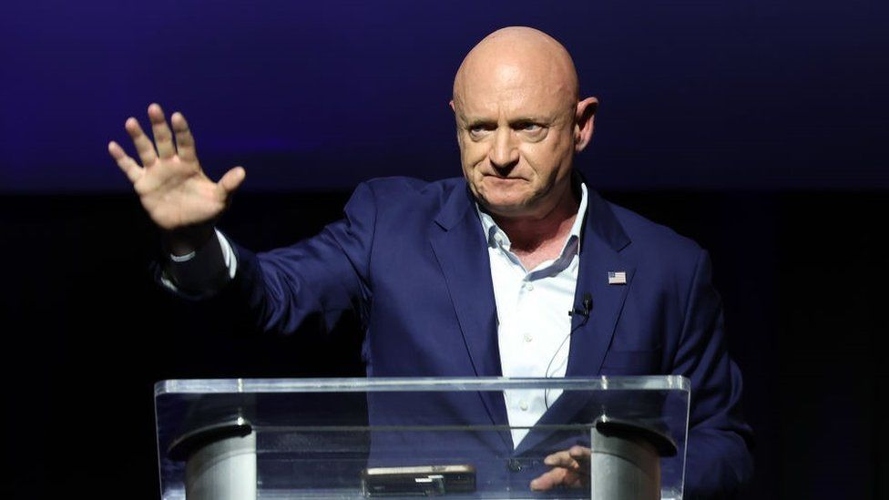IMAGE SOURCE,GETTY IMAGES

Image caption,

Democrat Mark Kelly, a former astronaut, beat Republican challenger Blake Masters

**By Jude Sheerin in Washington & George Wright in London**

BBC News

**US President Joe Biden's Democrats have inched closer to keeping control of the Senate, with a projected win in Arizona following the midterm elections.**

Three days after Americans voted, the BBC's US partner CBS estimates Democrat Mark Kelly has beaten Republican challenger Blake Masters.

That would leave the Senate at 49 Democratic seats and 49 Republican seats.

Just Nevada and Georgia are yet to be decided.

The vote count in Nevada is neck and neck, while Georgia's race will be settled by a run-off election next month.

If Democrats win either of the two remaining races they will remain in control of the upper chamber of Congress because the US vice-president can cast a tie-breaking vote on their behalf.

Republicans could still take control of the US House of Representatives as votes continue to be tallied from a handful of districts after Tuesday's elections.

If the Republicans win either or both chambers of Congress they could thwart much of Mr Biden's agenda.

Mr Kelly, a former astronaut whose wife, Gabby Giffords, survived an assassination attempt when she was a US lawmaker, was first elected two years ago to serve out the remainder of the late John McCain's Senate term.

In a statement, Mr Kelly said: "From day one, this campaign has been about the many Arizonans - Democrats, Independents, and Republicans - who believe in working together to tackle the significant challenges we face.

"That's exactly what I've done in my first two years in office and what I will continue to do for as long as I'm there."

Mr Masters, a 36-year-old venture capitalist, had been endorsed by former President Donald Trump without political experience. He had refused to accept the 2020 election results and repeated false claims of election fraud.

In an email to supporters on Thursday, the Masters campaign said it had seen "troubling" issues during the election and asked for contributions, the New York Times reported.

"We're expecting a contested road forward and legal battles to come," it said.

The result is another blow to the Republicans, who were hoping for a "red wave" - an electoral rout which would deliver a harsh rebuke of President Joe Biden and the Democrats.

While the party has made modest gains and remains favoured to win the House of Representatives, the Senate remained hotly contested and the Democrats have performed better than expected.

Mr Biden has said the election was a "good day" for US democracy.

* [**Why a Republican 'wave' never happened**](https://www.bbc.co.uk/news/world-us-canada-63569850)
* [**How Republican Ron DeSantis conquered Florida**](https://www.bbc.co.uk/news/world-us-canada-63565224)
* [**Why Trump is attacking his Republican rivals**](https://www.bbc.co.uk/news/world-us-canada-63601135)

The midterm elections are for Congress, which is made up of two parts - the House of Representatives and the Senate.

Congress makes nationwide laws. The House decides which laws are voted on while the Senate can block or approve them, confirm appointments made by the president and, more rarely, conduct any investigations against him.

These votes are held every two years and when they fall in the middle of the president's four-year term of office.

Each state has two senators, who sit for six-year terms. Representatives serve for two years, and represent smaller districts.

All the seats in the House of Representatives were up for election in the midterms, alongside one-third of the Senate.

Several major states also have elections for their governor and local officials.

Takeoff: Drake and Justin Bieber join fans at Atlanta memorial to Migos rapper

* Published

7 hours ago

Share

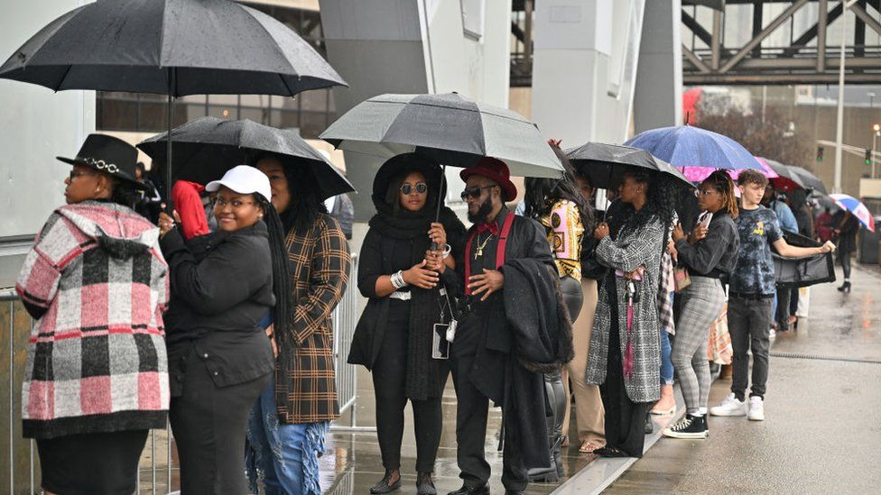IMAGE SOURCE,GETTY IMAGES

Image caption,

Fans braved the rain to attend Friday's "celebration of life" for late Migos rapper Takeoff

**By Sam Cabral**

BBC News

**Thousands of fans have paid their final respects to the Migos rapper Takeoff at a star-studded memorial service in Atlanta, Georgia.**

Stars including Drake, Justin Bieber and Chloe Bailey were all reported to be in attendance at Friday's "celebration of life" ceremony.

The 28-year-old musician died in a shooting at a bowling alley in Houston, Texas earlier this month.

Police are still investigating and have made no arrests.

Fans braved the rain to attend the roughly three-hour event at the State Farm Arena, a 21,000-capacity stadium.

Relatives - including the two surviving members of Migos, his uncle Quavo and his cousin Offset - led with heartfelt tributes to the young artist.

Atlanta Mayor Andre Dickens gave the late rapper, whose real name is Kirshnik Khari Ball, the city's highest honour: the Phoenix Award.

The event also featured musical performances from Bieber, Bailey, and gospel artists Yolanda Adams and Byron Cage.

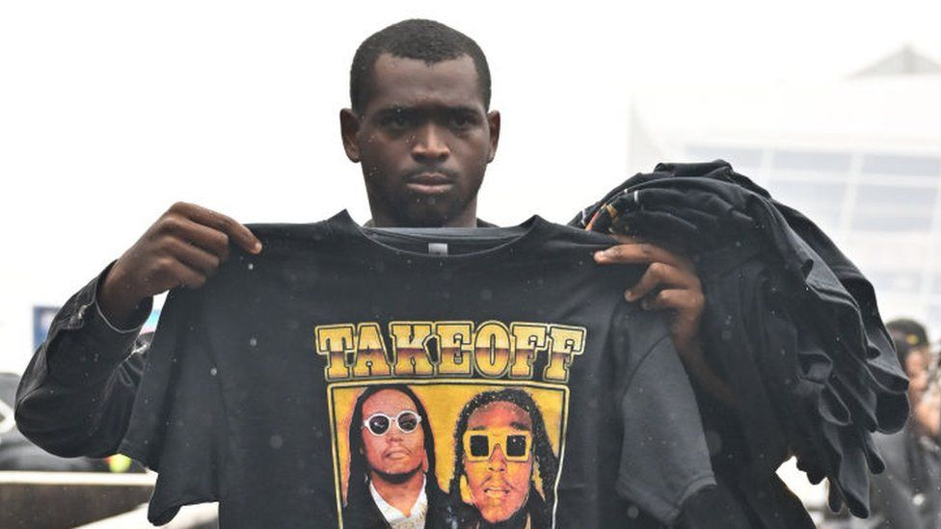IMAGE SOURCE,GETTY IMAGES

Image caption,

A fan holds up a shirt honouring Takeoff as he stands in linefor the memorial service

No media was allowed inside the venue, and phones and recording devices were also banned.

But in images and videos leaked on social media, Drake and others were shown making heartfelt speeches.

Following the event, a motorcade was seen carrying Takeoff's body to its final resting place.

The rapper was killed on 1 November by a stray bullet after an altercation broke out at a private party he was attending in Houston.

Police Chief Troy Finner, who has said at least 40 eye-witnesses may have been in attendance, has pleaded with the community to provide information.

Top US border official Chris Magnus told to resign or be fired

* Published

9 hours ago

Share

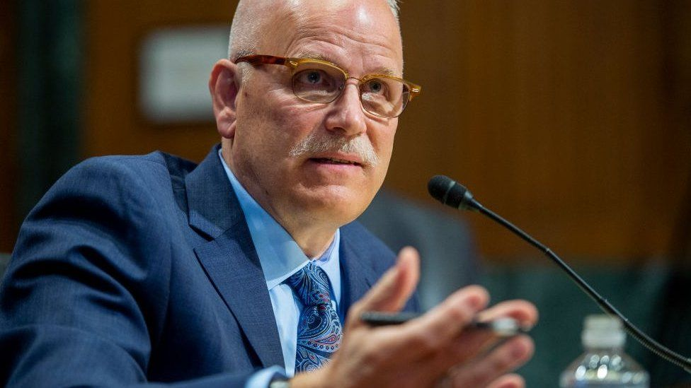IMAGE SOURCE,GETTY IMAGES

Image caption,

Chris Magnus has been commissioner of the US Customs and Border Protection for less than a year

**The top official tasked with overseeing US border security says he has been asked to resign or be fired.**

Customs and Border Protection Commissioner Chris Magnus said he had been asked to step down by the homeland security secretary.

Mr Magnus has refused to do so and has defended his work with the federal agency, reports say.

The number of illegal crossings at the US-Mexico border reached a record high this year, prompting heavy criticism.

"I felt there was no justification for me to resign when I still cared deeply about the work I was doing," Mr Magnus told the Los Angeles Times newspaper.

Mr Magnus, a former police chief, was asked last year by President Joe Biden to run US Customs and Border Protection. He has been commissioner of the federal agency for less than a year.

The agency has been under intense scrutiny by members of the Republican Party after illegal crossings into the US soared.

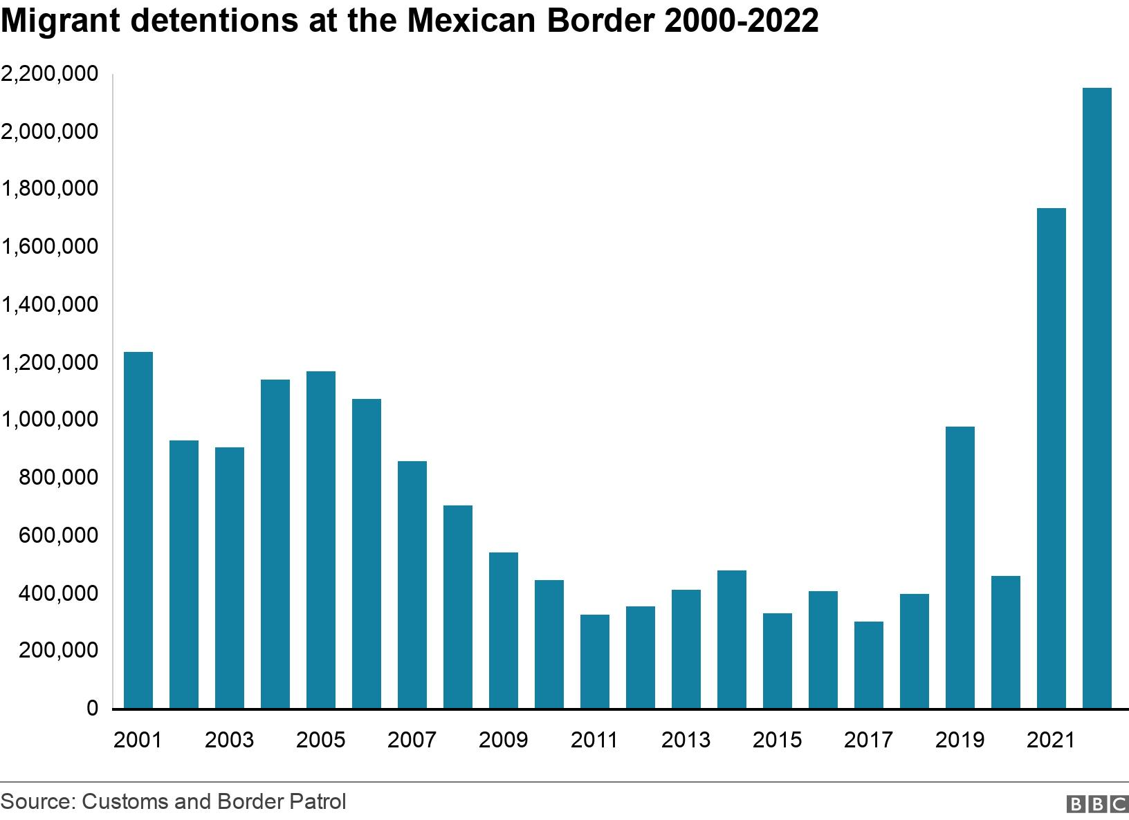

Around 227,500 migrants were stopped at the US-Mexico border in September, up 18.5% from the same time in 2021.

Most arrived from Venezuela, Cuba and Nicaragua - countries that have suffered deteriorating political and economic conditions.

The crossings have become an intensely political issue, with Republican governors sending busses filled with migrants to Democratic states in a bid to increase pressure on the Biden administration to reduce the number of people crossing.

Mr Magnus said he was told that Alejandro Mayorkas, the homeland security secretary, had lost confidence in him and believed he had not done enough to address the high number of illegal crossings.

Republicans have threatened to impeach Mr Mayorkas if they take control of the House of Representatives after the US midterm elections.

Remains of US soldier Tommie Hanks identified after 72 years

* Published

12 hours ago

Share

IMAGE SOURCE,DPAA HANDOUT

Image caption,

Tommie T Hanks will be buried at Arlington National Cemetery with full military honours

**The remains of a US soldier have been identified 72 years after he was killed and declared missing during the Korean War, the US government has said.**

Army Cpl Tommie T Hanks, then 27, was killed after his unit attempted to withdraw from a location near Anju in North Korea in 1950.

His body was declared "non-recoverable" six years later.

Nearly 7,600 of those killed in the war are still unaccounted for, according to the US defence department.

The Defense POW/MIA Accounting Agency (DPAA) said Cpl Hanks was reported missing in action on 26 November while his unit was attempting to withdraw from east of the Ch'ongch'on River near Anju.

"His remains could not be recovered, and there is no evidence that he was ever a prisoner of war," said the DPAA in a statement.

Hanks's identification became possible after North Korea turned over 55 boxes containing the remains of American service members killed during the Korean War.

* [**Veteran's search for faces of fallen comrades**](https://www.bbc.co.uk/news/uk-england-manchester-63571213)

It came after a summit between then-President Donald Trump and North Korean leader Kim Jong-un in June 2018.

To identify Hanks's remains, scientists used anthropological and isotope analysis, as well as circumstantial evidence.

He will be buried at Arlington National Cemetery on a date yet to be determined.

Since 1982, the remains of over 450 Americans killed in the Korean War have been identified and returned to their families for burial with full military honours.

This number is in addition to the roughly 2,000 Americans whose remains were identified in the years following the end of hostilities, when the North Korean government returned over 3,000 sets of remains to the US.

The DPAA says the remains of hundreds of service members still unaccounted for are classified as "non-recoverable".

The Korean War is considered the deadliest conflict of the Cold War era, according to the DPAA, with the US suffering approximately 36,500 casualties.

Donald Trump: Why is he suddenly attacking Ron DeSantis?

* Published

13 hours ago

Share

Related Topics

* [**US midterm elections 2022**](https://www.bbc.com/news/topics/c0311km5r1lt)

IMAGE SOURCE,GETTY IMAGES

Image caption,

Happier times...

[**By Anthony Zurcher**](https://www.bbc.co.uk/news/correspondents/anthonyzurcher)

North America correspondent

[@awzurcher](https://www.twitter.com/awzurcher)



**Here we go again. Seven years ago, Donald Trump was feuding with the Rupert Murdoch conservative media empire and launching ruthless attacks against a Florida governor who many Republicans had anointed their leading presidential contender.**

The real-estate magnate was then the ultimate outsider, seeking to tear down the political establishment - left and right - on his path to the White House.

Mr Trump achieved that goal, and spent a tumultuous four years as president, but a chaotic end to his term in office and two years out of the spotlight have left him lobbing bombs from the political sidelines once more.

Now it's Florida Governor Ron DeSantis, not ex-governor Jeb Bush, who is the prime target of Mr Trump's resentment. And while the ex-president still has allies at Fox News, its coverage has treated Mr Trump like an afterthought and the Murdoch-run New York Post and Wall Street Journal appear to be on a vendetta against their former hometown celebrity.

According to anonymous insider reports, Mr Trump still harbours presidential ambitions - and is leaning toward announcing another presidential bid from his Mar-a-Lago home next Tuesday. After this week's disappointing midterm results for Republicans, where Mr Trump's hand-picked candidates struggled to win key races, the former president's advisers are counselling him to wait for the dust to settle.

Instead, with his Thursday social media posts and evening press-release diatribe against Mr DeSantis, Mr Murdoch's Newscorp and all his critics, Mr Trump seems intent on throwing that dust in his enemy's eyes. He called his Florida rival an "average Republican governor with great public relations" and made explicit the parallels to his first presidential bid.

"This is just like 2015 and 2016, a Media Assault (Collusion!), when Fox News fought me to the end until I won, and then they couldn't have been nicer or more supportive," he wrote. "The Wall Street Journal loved Low Energy Jeb Bush, and a succession of other people as they rapidly disappeared from sight, finally falling in line with me after I easily knocked them out, one by one."

* [**How bad was Donald Trump's night?**](https://www.bbc.co.uk/news/world-us-canada-63569844)
* [**Why a Republican 'wave' never happened**](https://www.bbc.co.uk/news/world-us-canada-63569850)

On Friday morning, Mr Trump's attention turned to another possible Republican presidential rival, Virginia Governor Glenn Youngkin. He wrote on his social media site that the name "sounds Chinese" and noted that the Virginian couldn't have been elected without the ex-president's support. (Mr Youngkin pointedly tried to distance himself from Mr Trump during his successful 2021 governor campaign.)

All this is a familiar strategy - conducted with familiar viciousness and drama.

Media caption,

Watch: Five things to know about Ron DeSantis

In 2016, Mr Trump lashed out at prominent figures within his own party with no restraint - presidential rivals Mr Bush, Ben Carson, Ted Cruz and Marco Rubio, as well as Arizona Senator John McCain. He didn't need the respect or support of Republican leaders and wore their scorn as a badge.

At the time, those leaders feared Mr Trump would be a disastrous standard-bearer, that he would sink the party and doom them to defeat. Mr Trump won the White House anyway, but after this week - and the Republican midterm rout in 2018 and Mr Trump's 2020 re-election defeat - his party's elders are once again getting skittish.

"In '22 we're going to net-lose governorships, we're not going to pick up the number of seats in the House that we thought, and we may not win the Senate despite a president who has 40% job approval," said Chris Christie, the former New Jersey governor who ran against - and later endorsed - Mr Trump for president in 2016. "There's only one person to blame for that, and that's Donald Trump."

There are new twists to the story this time around, however.

Although the top of the party and its big-money donor base may want to move on from the ex-president, the grass-roots infrastructure of the Republican Party is run by those faithful to Mr Trump.

Republicans may have struggled this year, but they picked up congressional seats in 2016 and 2020, when Mr Trump's name was at the top of the ballot.

State legislatures and the US House of Representatives are stocked with Trump loyalists like Jim Jordan of Ohio, Andy Biggs of Arizona and Matt Gaetz of Florida.

"I am proud to endorse Donald J Trump for president in 2024," wrote Congresswoman Elise Stefanik of New York on Thursday, jumping the gun a bit on Mr Trump's possible presidential announcement.

"Republican voters determine who is the leader of the Republican Party, and it's very clear President Trump is the leader of the Republican Party."

Trump's recent attacks are also being picked up by his supporters, including Arizona governor candidate Kari Lake, who suggested that Mr DeSantis was being elevated over pro-Trump candidates. '

"Ron DeSantis goes out and gives his big speech and then they want to make it look like the Trump Republicans don't have a chance," she said during an interview on Thursday.

But Mr Trump's latest round of invective suggests that he feels under siege. And if, as indications suggest, he does run for president again, he will do so as a bomb-throwing renegade willing to tear the party down around him if challenged.

He and his supporters may have a penchant for referring to him as "President Trump" even in the year-plus since he left office, but he is an outsider once more.

Cruise ship with 800 Covid cases docks in Sydney

* Published

5 hours ago

Share

Related Topics

* [**Coronavirus pandemic**](https://www.bbc.com/news/topics/cyz0z8w0ydwt)

IMAGE SOURCE,GETTY IMAGES

Image caption,

About 4,600 passengers and crew were aboard the Majestic Princess (seen here in 2021)

**By George Wright**

BBC News

**A holiday cruise ship carrying about 800 passengers with Covid-19 has docked in Sydney, Australia.**

The Majestic Princess cruise ship arrived at Circular Quay, having sailed from New Zealand.

About 4,600 passengers and crew were aboard the ship when it docked - meaning around one in five had Covid.

The outbreak is reminiscent of the Ruby Princess cruise ship Covid outbreak of early 2020, [**where at least 900 people tested positive and 28 died.**](https://www.bbc.co.uk/news/world-australia-53776285)

Marguerite Fitzgerald, the president of cruise operator Carnival Australia, said a large number of cases started to be detected about halfway through the 12-day voyage.

All cases were either asymptomatic or mildly symptomatic, she said.

Staff would be assisting all guests who have tested positive "with accessing private transport and accommodation to complete their isolation period", she said. The ship will soon depart for Melbourne.

Asked about comparisons between the Majestic Princess and the Ruby Princess - which also belongs to the same operator - Ms Fitzgerald said: "Since then, we as a community have learnt a lot, a lot more about Covid."

The outbreak comes as Covid cases rise across Australia.

In New South Wales, 19,800 new cases were detected in the seven days to Friday.

US midterms: Local Kentucky races decided by coin toss

* Published

13 hours ago

Share

Related Topics

* [**US midterm elections 2022**](https://www.bbc.com/news/topics/c0311km5r1lt)

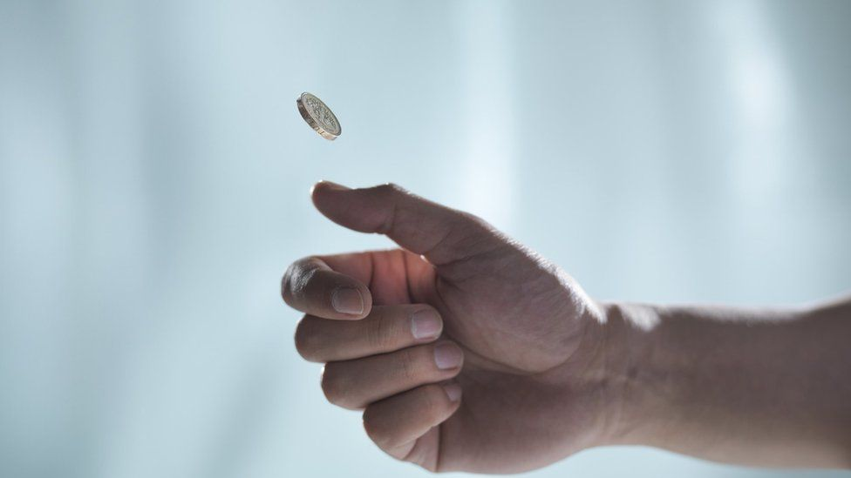IMAGE SOURCE,GETTY IMAGES

Image caption,

Local races that are tied in Kentucky are decided by lots, per state law

**How do you do a selection when an election is tied? In Kentucky, a coin toss will do the trick, according to state law.**

Not one, but two contests had resort to this method this week - one for a council seat, another for a magistrate.

The races were among many local elections that were held during the US midterm elections.

And on both occasions candidates were more than happy with the 50-50 chance provided by a flip and gravity.

The first took place in Breckinridge County - a small county south-west of Louisville - where candidates David Albright and Ronnie Robinson were vying for Fourth District magistrate.

* [**Midterm elections results: Three days on this is where the races stand**](https://www.bbc.com/news/world-us-canada-63586485)

Each of them received 572 votes, according to local reports, and the two agreed that one would flip a coin while the other chooses heads or tails to decide the winner.

Albright, who called heads, won.

In the race in nearby Muldraugh, a city council seat was also decided by a coin toss.

Candidates Deborah Noel and Sharon Hodge were asked by the local county clerk to choose heads or tails before the clerk flipped the coin.

Heads came out on top again, and Ms Noel will sit on the city council.

Construction halted at Obama Center after noose found

* Published

16 hours ago

Share

IMAGE SOURCE,GETTY IMAGES

Image caption,

Former US president Barack Obama and former first lady Michelle Obama recently attended a groundbreaking event at the site in September with Illinois governor JB Pritzker.

**Construction has been halted on the Obama Presidential Center in Chicago after a noose was found at the site.**

Lakeside Alliance, a group of Black-owned construction companies behind the project, said they reported the incident to police on Thursday.

They are offering a $100,000 (£85,000) reward to find the perpetrators.

In a statement, the Obama Foundation - the former president's non-profit organisation - called the incident a "shameless act of cowardice and hate".

"Our priority is protecting the health and safety of our workforce," the statement said.

Governor of Illinois JB Pritzker has also condemned the incident, writing on Twitter that "the noose is more than a symbol of racism."

"It is a heart-stopping reminder of the violence and terror inflicted on black Americans for centuries," Mr Pritzker said.

The firm behind the project said it was halting construction to provide anti-bias training to staff and workers.

"We have zero tolerance for any form of bias or hate on our worksite," Lakeside Alliance said in a statement.

The looped rope is synonymous with the extrajudicial hangings, or lynchings, of mainly black people in the United States in the late 19th and early 20th Centuries.

Work on the Center began in 2021, with Barack Obama and his wife Michelle attending a ground-breaking event last September.

The $500m (£424.3m) Center is due to open in 2025, and is expected to attract about 750,000 visitors a year.

On its website, the Obama Foundation said the Center "represents a historic opportunity to build a world-class museum and public gathering space that celebrates our nation's first African American President and First Lady on the South Side of Chicago".

Its construction has mostly been funded by private donations.

# Crypto giant FTX collapses into bankruptcy

* Published

14 hours ago

* comments

[Comments](https://www.bbc.com/news/business-63601213#comments)

Share

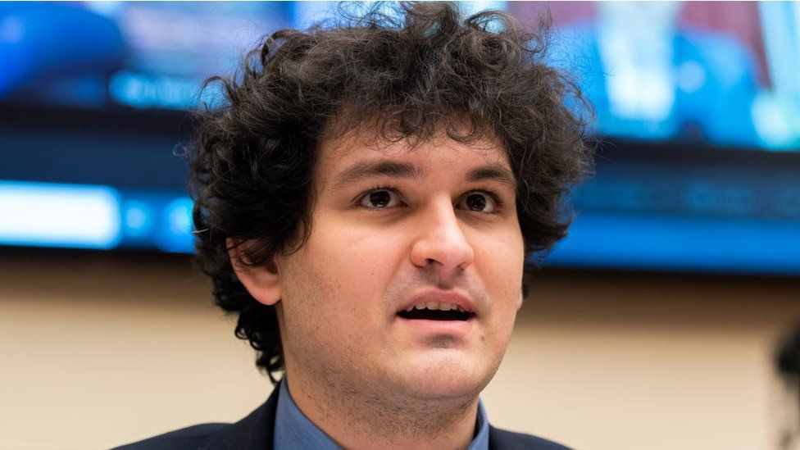IMAGE SOURCE,TOM WILLIAMS

Image caption,

FTX founder Sam Bankman-Fried stepped down as chief executive on Friday.

**By Natalie Sherman & Joe Tidy**

BBC News

**Embattled cryptocurrency exchange FTX has filed for bankruptcy in the US, seeking court protection as it looks for a way to return money to users.**

Former boss Sam Bankman-Fried has also stepped down as chief executive, the company said.

It is a massive turn of fortunes for the 30-year-old, who had headed the world's second largest crypto exchange.

In just over a week, his FTX empire has collapsed, shaking confidence in the already troubled crypto market.

"I'm really sorry, again, that we ended up here. Hopefully things can find a way to recover," Mr Bankman-Fried, nicknamed the 'King of Crypto', wrote on Twitter on Friday.

"I was shocked to see things unravel the way they did."

The BBC is not responsible for the content of external sites.[**View original tweet on Twitter**](https://twitter.com/SBF_FTX/status/1591089330323611648?s=20&t=AZlRQH3iLlXLrsEl5EGC8A)

Prior to the meltdown, Mr Bankman-Fried had been one of the stars of the crypto scene, drawing comparisons to investment magnate Warren Buffett, with a net worth estimated at more than $15bn (£12.8bn) as recently as Monday.

But rumours earlier this week that FTX and other firms owned by Mr Bankman-Fried were on shaky financial ground prompted a mass of customers to try to withdraw funds from FTX, an exchange used to buy and sell digital tokens.

Facing a cash crunch, Mr Bankman-Fried tried to organize a bailout but that failed, leaving FTX scrambling to raise billions of dollars and many customers unable to access their money.

* [**Crypto market rocked by near-collapse of exchange**](https://www.bbc.co.uk/news/business-63564364)
* [**'I'm waiting to get £2,000 back from crypto giant'**](https://www.bbc.co.uk/news/business-63577783)

By filing for Chapter 11 bankruptcy, the company can continue operating, while restructuring its debts under court supervision.

FTX said the goal was to "begin an orderly process to review and monetize assets for the benefit of all global stakeholders".

"The FTX Group has valuable assets that can only be effectively administered in an organised, joint process," said new chief executive John J Ray III, a lawyer who previously worked at a venture capital firm and has experience with high-profile bankruptcy cases.

In the filing, FTX estimated that it had between $10bn and $50bn in assets and liabilities and more than 100,000 creditors.

The proceeding involves FTX as well as Alameda Research, a trading firm founded by Mr Bankman-Fried, and roughly 130 affiliates, according to the statement FTX shared on Twitter.

Those include FTX's operations in the US, which Mr Bankman-Fried had said on Thursday were unaffected.

Mr Bankman-Fried said "this doesn't necessarily have to mean the end for the companies or their ability to provide value and funds to their customers chiefly, and can be consistent with other routes.

"Ultimately I'm optimistic that Mr. Ray and others can help provide whatever is best".

For now, Thomas Culham, from Kingston, said he has been unable to withdraw the £2,000 he had put into FTX - a "big blow" as his funds in FTX were "decent chunk" of his investment portfolio.

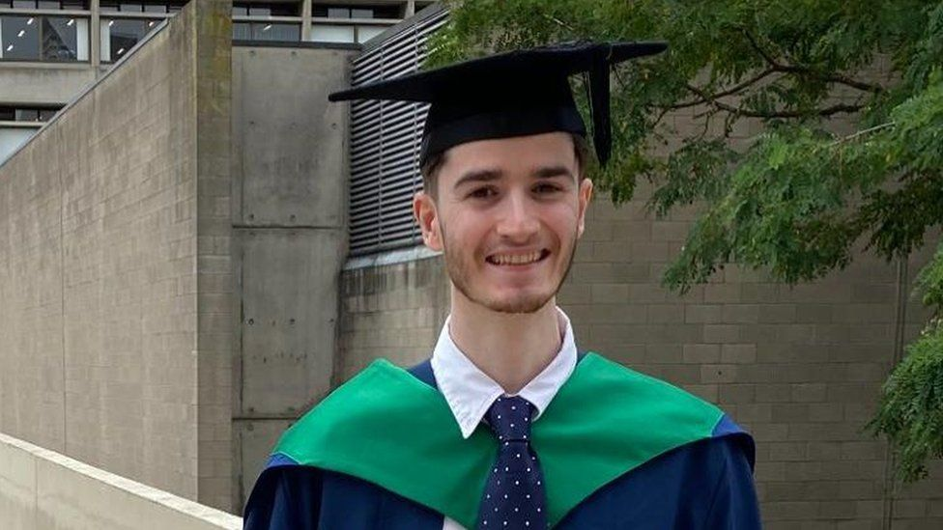IMAGE SOURCE,THOMAS CULHAM

Image caption,

Thomas Culham had £2,000 invested in FTX

"It's probably gone," the 22-year-old said. "Maybe in a few years' time I might get some sort of recovery - they do have assets [and] they should be able to liquidate them."

## Pressure on other firms

Mr Bankman-Fried had enjoyed a high-profile in the crypto industry and beyond, frequently speaking on behalf of the sector before regulators.

He was a major donor to Democrats in the most recent US elections and had gone on an advertising blitz in the country, enlisting celebrities such as Tom Brady and Gisele Bundchen to convince the public that crypto was a worthy investment.

But as he became a bigger figure, questions were raised about the ties between the different parts of his business empire and potential conflicts of interest between FTX and Alameda.

The troubles at his firms have hurt the rest of the crypto market, with currencies such as Bitcoin dropping 20% this week, and raised pressure on other companies to prove they have the financial strength to stay afloat.

Several companies in the sector had already collapsed or approached collapse earlier this year, after a sharp downturn in the value of digital assets. BlockFi, another crypto firm with ties to FTX, stopped clients from making withdrawals on Thursday because of the situation.

"FTX going down is not good for anyone in the industry. Do not view it as a win for us. User confidence is severely shaken," wrote Changpeng Zhao, the chief executive of FTX's larger rival, Binance, which had said it might buy FTX this week only to walk away.

Regulators have long warned of risks to crypto investors and raised concern about the threat of wider financial turmoil, as traditional financial companies expand their investments in the market, despite little regulation.

FTX, which is now reportedly under investigation by several financial authorities, had enjoyed backing from major investment firms, including Blackrock, Softbank and the Ontario Teachers' Pension Plan in Canada.

But Dan Ives, analyst at Wedbush Securities, said he did not think FTX's troubles would spark wider problems in the stock market.

"It's a black swan event. There's really no bleed over into the overall market, there's containment," he said. "That's extremely important and another positive signal in terms of the walls between systematic risk and not."

Mr Bankman-Fried admitted that the downfall is "on me" but that will be scant consolation to the potentially 1.2 million FTX customers who could now lose their crypto savings.

Despite potentially losing his money, Mr Culham said this week's events wouldn't put him off investing in more cryptocurrencies in the future.

"I think there's a lot of opportunity," he said, adding that he was not investing more than he could afford to lose, and also not investing in only one type of crypto.

*Additional reporting by Michael Race.*

Tobias White-Sansom: UK inquest to look into Spanish nightclub death

* Published

47 minutes ago

Share

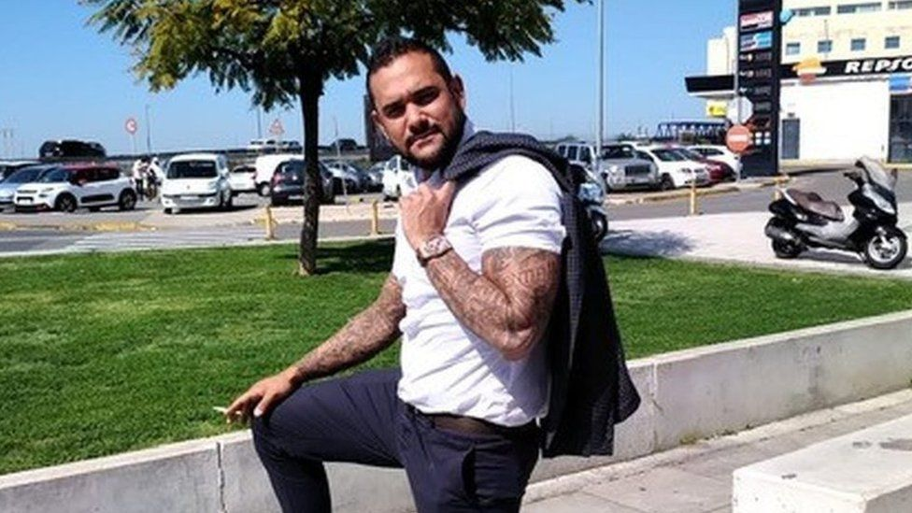IMAGE SOURCE,FAMILY HANDOUT

Image caption,

Tobias White-Sansom's family believe he was beaten and injected with a tranquiliser before suffering a cardiac arrest

**By Dan Martin**

BBC News

**The family of a British man who died after an altercation at a Majorcan nightclub has welcomed a UK coroner's investigation into his death.**

Tobias White-Sansom died in a Spanish hospital in July five days after a night out in Magaluf.

The 35-year-old's family dispute the findings of local investigations into his death.

His relatives said they were pleased a UK coroner will now examine evidence collected by the Spanish authorities.

Lorraine Thompson said her "amazing" son - a father-of-two from Nottingham - was pinned down by nightclub security staff following a row over him removing his T-shirt because he was too hot.

She told the BBC the Spanish Civil Guard - the Guardia Civil - were called and her son was handcuffed, tasered and injected with tranquilisers before going into cardiac arrest.

He was taken to hospital where he was kept in an induced coma before doctors advised his life support be switched off on 31 July.

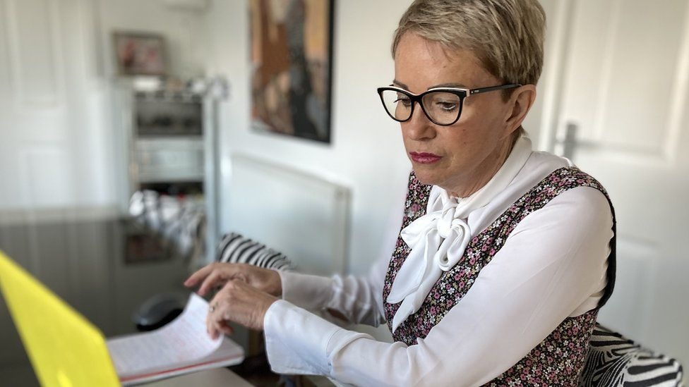

Image caption,

Lorraine Thompson said her son "did not go out looking for any sort of trouble"

Mrs Thompson has raised concerns about the thoroughness of the Spanish authorities' investigations in her son's death and she said she was pleased South Staffordshire Coroners Court have become involved.

The family has already arranged for a second private investigation into Mr White-Sansom's death.

Mrs Thompson said: "When the documentation came through to the UK there were a lot of statements made that were not properly substantiated.

"The UK coroner feels there are gaps and that it needs looking into seriously."

She said she wanted the circumstances of what happened that night to "be brought out into the open".

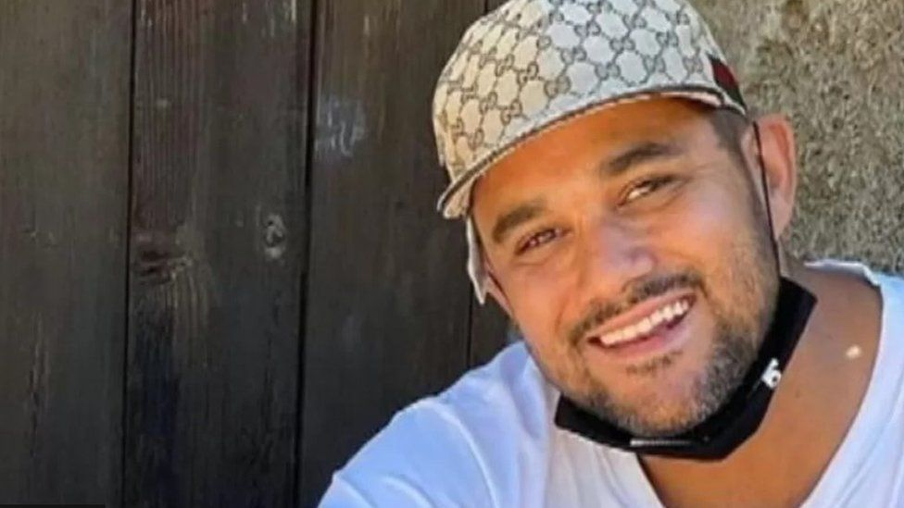IMAGE SOURCE,FAMILY HANDOUT

Image caption,

Tobias White-Sansom's family said they would continue to fight for accountability

Mrs Thompson said an autopsy in Spain had concluded her son's death was drugs-related.

His family disputes this and has asked for a second, independent, autopsy.

She added: "He was a handsome well-groomed man who didn't go out looking for any sort of trouble.

"We will continue fighting for justice for Toby and for those who have caused this to be held accountable."

The Guardia Civil has previously said in a statement: "Upon the arrival of the Guardia Civil police, this man was violent and police reduced him to be assisted by medical services.

"He was taken to the hospital for treatment. There, once while he was being assisted, he was arrested for a crime of injury."

South Staffordshire Coroners Court has confirmed an inquest into Mr White-Sansom's death has opened.

A coroner's spokesperson said: "A date for the resumed inquest has not yet been confirmed."

# G20 in Bali: Trouble in paradise as leaders gather

* Published

6 hours ago

Share

Related Topics

* [**Russia-Ukraine war**](https://www.bbc.com/news/topics/c1vw6q14rzqt)

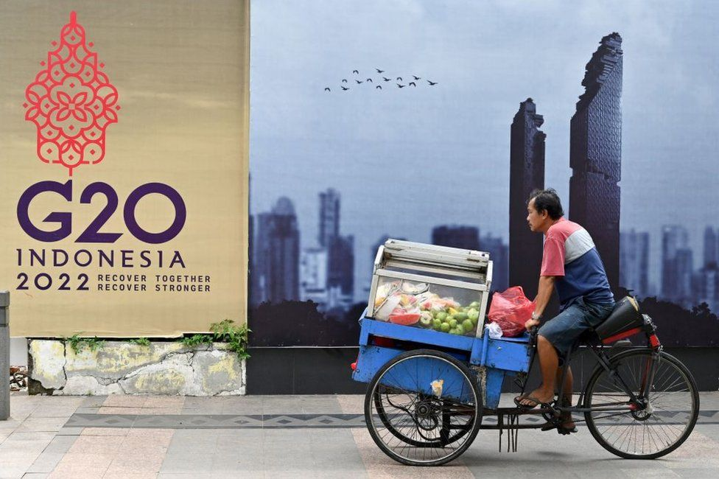IMAGE SOURCE,GETTY IMAGES

Image caption,

The Russia-Ukraine war and China's assertiveness have strained relations ahead of the summit

**By Karishma Vaswani**

Chief Asia Presenter

**An idyllic paradise of palm trees and pineapples, sun, sand and serenity is what comes to mind when you think of Bali.**

But this week the Indonesian island is hosting what could well be the most strained edition of the G20, or Group of 20 nations.

The annual summit - which includes 19 advanced and emerging economies and the EU - was created after the Asian financial crisis in 1999. And it considers itself something of a superpowers club that manages future crises.

And this time, there are plenty on the discussion block - the Russia-Ukraine war, brewing US-China tensions, soaring inflation, the ever-looming threat of a global recession, nuclear threats from North Korea, and perhaps most alarming of all, a rapidly warming earth.

Amid all this, host and Indonesian President Joko Widodo hopes to play chief dealmaker. Can he do it?

## An era of living dangerously

When we spoke ahead of the G20 meeting, Mr Widodo seemed sanguine about what has been described as the most diplomatically delicate and stressful G20 ever.

US President Joe Biden and China's leader Xi Jinping are set to meet on Monday - and the clash of the world's two largest economies has Mr Widodo worried.

"There can be no peace without dialogue," he told me in an exclusive interview at the presidential palace in Jakarta.

"If President Xi Jinping and President Joe Biden can meet and talk, it would be very good for the world, especially if they are able to come to an agreement about how to help the world recover."

Like many Asian countries, Indonesia has benefited from decades of free trade and multilateralism. The US has always been Indonesia's most important global strategic partner, but over the last decade, China has consistently ranked as [**one of its top two foreign investors**](https://www5.investindonesia.go.id/en/article-investment/detail/here-are-5-countries-with-biggest-foreign-direct-investment-in-indonesia).

That's made navigating the relationship between the two giants tricky, to say the least.

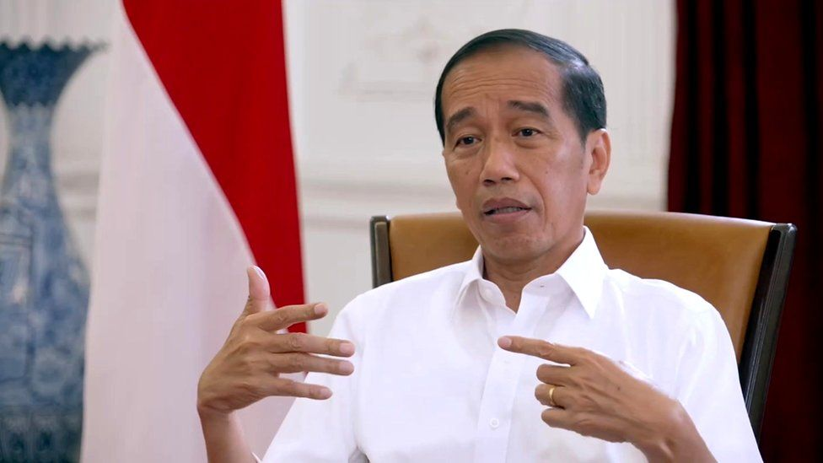

Image caption,

"There can be no peace without dialogue," says Joko Widodo - popularly known as Jokowi

An era in which China and the US aren't getting along is a far more dangerous one than Indonesia and other Asian countries have been accustomed to.

Observers say that that growing tensions between Washington and Beijing increase the risk of conflict in the Indo-Pacific.

Meanwhile there are also fears of the possible use of nuclear weapons, either in Ukraine or on the Korean peninsula, where Pyongyang has fired a record number of missiles this year.

"The use of nuclear weapons for any reason, cannot be tolerated," Mr Widodo, also known as Jokowi, says. "The increasing potential for nuclear use is… very dangerous for peace and for world stability."

## Getting people to talk

A key issue for Mr Jokowi personally has been food security - particularly as the war in Ukraine has been responsible, in his view, for rising prices, something that directly impacts Indonesia's 275 million people.

He politely termed Russia's invasion of Ukraine a "headache", something that has been "taking up his mind".

* [**The US wants to play in China's backyard**](https://www.bbc.co.uk/news/world-asia-63565875)
* [**Can the US live in Xi Jinping's world?**](https://www.bbc.co.uk/news/world-asia-china-63386954)

Securing a steady and consistent resumption of grain exports is one of the reasons why - ahead of the meeting - he's crisscrossed the globe, meeting with Presidents Vladimir Putin and Volodymyr Zelensky to convince them to come to the meeting.

He had hoped they could talk. "I think it would be great if they [Presidents Vladimir Putin and Volodymyr Zelensky] could sit at the same table - to solve the problems that exist, because the problems that we are dealing with now are on all fronts," Mr Widodo said.

Mr Putin is not coming, Russian diplomats have since said, but Mr Zelensky could attend virtually.

## Jokowi's swansong

The G20 is as much Indonesia's coming out party as it is Mr Widodo's swansong - he is in the final stretch of his presidency, and in 2024 he will have to stand down after two terms in power.

When I first met him in 2012, as the then Jakarta governor he was a younger and more idealistic. Branded the first "outsider" to become president in Indonesia's history, he was elected as a man of the people, a democrat's democrat.

Since then he's had to govern a vast archipelago of 17,000 islands, a country that from west to east stretches the distance between London and Baghdad, with hundreds of different languages and ethnicities in between.

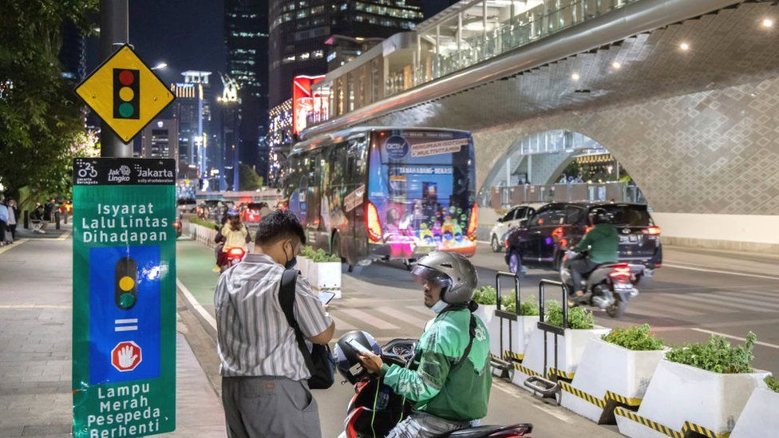IMAGE SOURCE,GETTY IMAGES

Image caption,

Mr Widodo wants to cement his economic legacy in Indonesia - but it may be out of his hands

It's a challenge [**I've written about before**](https://www.bbc.com/news/world-asia-47945625) and over the last few years I've seen Jokowi, man of the people, transform into Jokowi the president. Now a pragmatist, he's become a coalition-builder; someone who knows he has to compromise to not just survive but also thrive. Critics say he is no longer the democrat he used to be. Human rights groups and environmental campaigners have both said that he has consistently put the economy ahead of democratic interests.

Although he remains extremely popular by international standards, his [**approval ratings have fallen**](https://www.thejakartapost.com/indonesia/2022/09/19/fuel-price-hike-takes-toll-on-jokowis-popularity.html)) recently, partly because of rising prices.

Yet the country has weathered the current economic slowdown better than others, described by the International Monetary Fund as a [**"good performer" among regional economies**](https://www.imf.org/en/News/Articles/2022/10/14/tr101322-transcript-of-asia-and-pacific-department-press-briefing).

It is obvious Mr Widodo is keen to preserve and grow the economic legacy he is leaving behind for Indonesia.

"What we would like to see in 2045 is that Indonesia's golden era will truly be realised," he says towards the end of our conversation. "By 2030, we expect Indonesia to become the number seven economy in the world."

It is a lofty ambition, and one that will resonate with many of his citizens. But it's also one that may be out of his hands.

Indonesia's future depends on a stable global economic environment - something Mr Widodo hopes to come closer to securing at next week's G20 summit.

­­­

# Iranians mark ‘Bloody Friday’ as thousands protest in southeast flashpoint

By Reuters

Published 12:16 AM EST, Sat November 12, 2022



Protesters in Zahedan, the capital of Iran's Sistan and Baluchestan Province, on November 11, 2022.

ICHRI

Thousands of Iranians protested in the restive southeast on Friday to mark a Sept. 30 crackdown by security forces known as “Bloody Friday” as the country’s clerical rulers battled persistent nationwide unrest.

Amnesty International said security forces unlawfully killed at least 66 people in September after firing at protesters in Zahedan, capital of flashpoint Sistan-Baluchistan province. Authorities said dissidents had provoked the clashes.

A video posted by the widely followed 1500 Tasvir activist Twitter account purported to show thousands marching again in Zahedan on Friday. The authenticity of the footage could not be verified.

Another video which 1500 Tasvir said was from the town of Khash in the southeast showed protesters trampling and breaking a street sign carrying the name of top general Qassem Soleimani, who was assassinated in a US drone attack in 2020 in Iraq.

[[](https://edition.cnn.com/2022/09/24/middleeast/mahsa-amini-death-iran-internet-un-investigation-intl-hnk/index.html)](https://edition.cnn.com/2022/09/24/middleeast/mahsa-amini-death-iran-internet-un-investigation-intl-hnk/index.html)

[Young Iranians are rising up against decades of repression -- arguably bolder than ever](https://edition.cnn.com/2022/09/24/middleeast/mahsa-amini-death-iran-internet-un-investigation-intl-hnk/index.html)

Popular anger ahead of the Sept. 30 shooting was fueled by allegations of the rape of a local teenage girl by a police officer. Authorities have said the case is being investigated.

[Anti-government demonstrations](https://www.cnn.com/specials/middleeast/iran) also started erupting that month after the death of a Kurdish woman, [Mahsa Amini](https://www.cnn.com/2022/10/26/middleeast/iran-clashes-mahsa-amini-grave-intl), who had been detained by morality police for allegedly flouting the Islamic Republic’s strict dress code imposed on women.

Nationwide demonstrations have since turned into a popular revolt, with people ranging from students to doctors, lawyers, workers and athletes taking part, with fury directed mostly at Supreme Leader Ayatollah Ali Khamenei.

A group of countries led by Germany and Iceland requested a debate on the “deteriorating” situation in Iran at the UN top human rights body later this month, a document showed.

## Grievances, trials

The government, which has blamed Amini’s death on preexisting medical problems, has said the protests are fomented by Iran’s foreign enemies including the United States, and has vowed to reestablish order.

It accuses armed separatists of perpetrating violence and seeking to destabilize the Islamic Republic.

Some of the worst unrest has been in areas home to minority ethnic groups with long-standing grievances against the state, including the Sistan-Baluchistan and Kurdish regions.

Sistan-Baluchistan, near Iran’s southeastern border with Pakistan and Afghanistan, is home to a Baluch minority estimated to number up to 2 million people. They have faced discrimination and repression for decades, according to human rights groups. Iran denies that.

# 10,000 brains in a basement: The dark and mysterious origins of Denmark’s psychiatric brain collection

By Samantha Bresnahan, Dr. Sanjay Gupta, Susanne Gargiulo and Sandy Thin, CNN

Updated 6:45 AM EST, Fri November 11, 2022

**Editor’s Note:**Watch the special documentary, “World’s Untold Stories: The Brain Collectors,” November 12-13 on CNN International.

**CNN —**

For years, there had been whispers. Rumors swirled; stories exchanged. It wasn’t a secret, but it also wasn’t openly discussed, adding to a legend almost too incredible to believe.

Yet those who knew the truth wanted it out.

Tell everyone our story, they said, about the brains in the basement.

## A family secret

As a child, Lise Søgaard remembers whispers, too, though these were different – the family secret kind, hushed because it was too painful to speak it out loud.

Søgaard knew little about it, except that these whispers centered on a family member who seemed to exist solely in one photograph on the wall of her grandparent’s house in Denmark.

The little girl in the picture was named Kirsten. She was the younger sister of Søgaard’s grandmother, Inger – that much she knew.

**AD**

“I remember looking at this girl and thinking, ‘Who is she?’ ‘What happened?’” Søgaard said. “But also this feeling of a little bit of a horror story there.”

As she grew into adulthood, Søgaard continued to wonder. One day in 2020, she went to visit her grandmother, now in her mid-90s and living at a care home in Haderslev, Denmark. After all that time, she finally asked about Kirsten. Almost as if Inger had been waiting for that very question, the floodgates opened, and out poured a story Søgaard never expected.

Upper left: Kirsten (top center) and her sister Inger (bottom left) on a family outing with their aunt, uncle and cousin.
Lower left: The Abildtrup family in the early 1930s. Kirsten, center left holding her mother's hand, was the youngest of seven children.
Right: The photo of Kirsten that hung on the wall and first caught Søgaard's attention as a young girl.

Upper left: Kirsten (top center) and her sister Inger (bottom left) on a family outing with their aunt, uncle and cousin. Lower left: The Abildtrup family in the early 1930s. Kirsten, center left holding her mother's hand, was the youngest of seven children. Right: The photo of Kirsten that hung on the wall and first caught Søgaard's attention as a young girl.

Lise Søgaard

Kirsten Abildtrup was born on May 24, 1927, the youngest of five brothers and her sister, Inger. As a child, Inger remembers Kirsten as quiet and smart, the two sisters sharing a close bond. Then, when Kirsten was around 14 years old, something began to change.

Kirsten experienced outbursts and prolonged bouts of crying. Inger asked her mother if it was her fault, often feeling that way because the two girls were so close.

“At Christmas, they were supposed to go on a visit to some family members,” Søgaard said, “but my great-grandmother and father, they stayed home and sent all of their children away except for Kirsten.”

When they got back from that family visit, Søgaard said, Kirsten was gone.

It was the first of many hospitalizations, and the start of a long and painful journey that would ultimately end in Kirsten’s death.

The diagnosis: schizophrenia.

## The brain collectors

Kirsten was first hospitalized towards the end of World War II, when Denmark and the rest of Europe were at last on the verge of peace.

Like so many places, Denmark was also grappling with mental illness. Psychiatric institutions had been built across the country to provide care for patients.

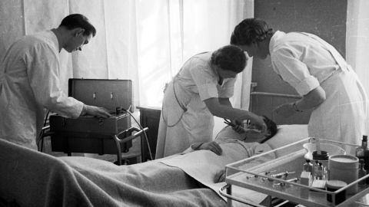

Doctors prepare a patient for electroshock therapy at Augustenborg Psychiatric Hospital in Denmark, 1943.

A E Andersen/Ritzau Scanpix/AP

But there was limited understanding of what was happening in the brain. The same year peace came to Denmark’s doorstep, two doctors working in the country had an idea.

When these patients died in psychiatric hospitals, autopsies were routinely performed. What if, these doctors thought, the brains were removed – and kept?

Thomas Erslev, historian of medical science and research consultant at Aarhus University, estimates that half of all psychiatric patients in Denmark who died between 1945 and 1982 contributed – unknowingly and without consent – their brains. They went to what became known as the Institute of Brain Pathology, connected to the Risskov Psychiatric Hospital in Aarhus, Denmark.

Doctors Erik Stromgren and Larus Einarson were the architects. After roughly five years, said Erslev, pathologist Knud Aage Lorentzen took over the institute, and spent the next three decades building the collection.

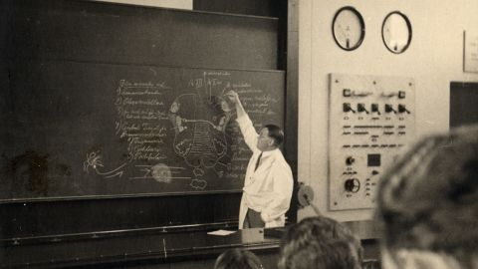

Dr. Larus Einarson, shown here teaching a class, was one of the co-founders of the brain collection at the Institute of Brain Pathology.

Arne Sell/Aarhus University

The final tally would amount to 9,479 human brains – believed to be the largest collection of its kind anywhere in the world.

## Nearly 10,000 brains on the move

In 2018, pathologist Dr. Martin Wirenfeldt Nielsen got a call. The brain collection, as it would come to be known, was on the move.

A lack of funding meant it could no longer stay in Aarhus, but the University of Southern Denmark in the city of Odense had offered to pick up the mantle. Would Wirenfeldt Nielsen be interested in overseeing it?

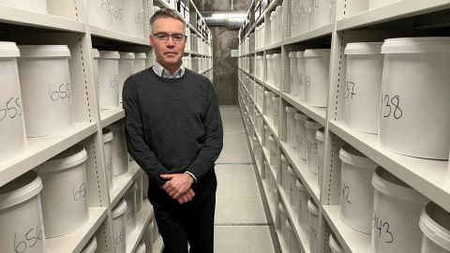

Pathologist Dr. Martin Wirenfeldt Nielsen now oversees the brain collection, housed in Odense, Denmark.

Samantha Bresnahan/CNN

“I’d sort of heard of it in the periphery,” Wirenfeldt Nielsen recalled. “But my first real knowledge about the vast extent of it was when they decided to move it down here … (because) how do you actually move almost 10,000 brains?”

The yellowish-green plastic buckets housing each brain, preserved in formaldehyde, were placed into new white buckets that were sturdier for the transport, and hand-labeled in black marker with a number. And then the brains, give or take a few (no one knows where bucket #1 is, for example) made their way to their new home in a large basement room on the university’s campus.

“The room wasn’t actually ready when they moved it down here,” Wirenfeldt Nielsen said. “The whole collection was just standing there, buckets on top of each other, in the middle of the floor. And that’s when I saw it for the first time … That was like, okay, this is something I’ve never seen before.”

## An ethical reckoning

Eventually, the nearly 10,000 buckets were placed on rolling shelves, where they remain today – waiting – representing lives, and a range of psychiatric disorders.

There are roughly 5,500 brains with dementia; 1,400 with schizophrenia; 400 with bi-polar disorder; 300 with depression, and more.

What separates this collection from any other in the world is that the brains collected during the first decade are untouched by modern medicines – a time capsule of sorts, for mental illness in the brain.

“Whereas other brain collections … (are) maybe specified for neurodegenerative diseases, dementia, tumors, or other things like that – we really have the whole thing here,” Wirenfeldt Nielsen said.

But it has not been without controversy. In the 1990s, the Danish public got wind of the collection, which had been sitting idle since former director Lorentzen’s retirement in 1982.

It would kick off one of the first major ethical science debates in Denmark.

## A history of The Brain Collection

## **1945**

The Institute of Brain Pathology is founded, connected to the Risskov Psychiatric Hospital in Aarhus, Denmark

Risskov, pictured here in the early 1900s.

Credit: Museum Ovartaci

## **1945-1982**

Nearly 9,500 brains are collected without permission from deceased psychiatric patients across the country

Brains were collected and sent from Danish hospitals, including Rigshospitalet (pictured) in Copenhagen.

Credit: Jesper Vaczy/Medical Museum

## **1982**

The head of the brain collection, Knud Aage Lorentzen, retires. Nobody takes his place, and the collection sits untouched in a basement

The brains, shown here in their original yellow buckets, would remain largely untouched for more than 20 years.

Credit: Hanne Engelstoft

## **1987**

The Danish Council of Ethics is established

The Council of Ethics is an independent group formed to advise the Danish parliament (pictured here in 2016) on ethical matters.

Credit: olli0815/iStock/Getty Images

## **1991**

After the Council of Ethics says the brains can be used with certain restrictions in place, SIND (Denmark’s national association for psychiatric health) demands the brains be buried – sparking one of the first major ethical science debates in Denmark

Some pieces of brain material are preserved in paraffin wax.

Credit: Hanne Engelstoft

## **2005**

Danish scientist Karl-Anton Dorph-Petersen takes over the collection’s daily maintenance at Aarhus

Karl-Anton Dorph-Petersen helped revive and preserve the collection in the mid-2000s.

Credit: Hanne Engelstoft

## **2006**

The Council of Ethics goes against political and religious demands by ruling it is ethically sound to use deceased psychiatric patient brains for research without getting the consent of relatives. This time, SIND agrees

The collection includes patient records and tissue preserved on slides, such as these.

Credit: Hanne Engelstoft

## **2017-2018**

A lack of funding threatens the brains, and the collection is saved by moving it to Odense, where Dr. Martin Wirenfeldt Nielsen takes over

The brains were put into new white buckets to move to Odense, where they remain safely stored on rolling shelves.

Credit: Samantha Bresnahan/CNN

Source: Thomas Erslev, historian of medical science

Graphic: Woojin Lee, CNN

“There was a discussion back and forth, and one position was that we should destroy the collection – either bury the brains or get rid of them in any other ethical way,” said Knud Kristensen, the director of SIND, the Danish national association for mental health, from 2009 to 2021, and current member of Denmark’s Ethical Council. “The other position said, okay, we already did harm once. Then the least we can do to those patients and their relatives is to make sure that the brains are used in research.”

After years of intense debate, SIND changed its position. “All of a sudden, they were very strong proponents for keeping the brains,” Erslev said, “actually saying this might be a very valuable resource, not only for the scientists, but for the sufferers of psychiatric illness because it might prove to benefit therapeutics down the line.”

“For (SIND),” Kristensen said, “It was important where it was placed and to make sure that there would be some sort of control of the future use of the collection.”

By the time it moved to Odense in 2018, the ethical debate was largely settled, and Wirenfeldt Nielsen became caretaker of the collection.

A few years later, he would get a message from Søgaard. Was it possible, she asked, that he had a brain there belonging to a woman named Kirsten?

## Searching for Kirsten

In the search for what happened to her great aunt Kirsten, Søgaard realized there were clues all around her. But piecing together what exactly had happened to her grandmother’s sister was slow, filled with dead ends and false starts.

Yet she was enthralled, and began officially reporting her journey for Kristeligt Dagblad, the Copenhagen-based newspaper where she worked – eventually bringing it to light in a [series of articles](https://www.kristeligt-dagblad.dk/historier/kirstens-brain).

At one point, Søgaard decided to focus on a single word her grandmother had told her, the name of a psychiatric hospital: Oringe.

“I opened my computer and I searched for ‘Oringe patient journals,’” she said. After putting in a request through the national archives, “I got an email that said, ‘Okay, we found something for you, come have a look if you want.’ … I felt this excitement … like, she’s out there.”

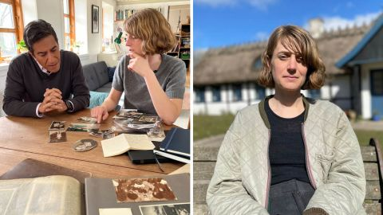

Journalist Lise Søgaard made it her mission to find out what happened to her grandmother's little sister, Kirsten -- a journey that would take her places she never imagined. She shared that experience with CNN's Dr. Sanjay Gupta at her home outside Copenhagen in April 2022.

Cameron Bauer and Samantha Bresnahan/CNN

That excitement was short-lived. At the national archives, they placed a mostly empty file in front of her. It wasn’t much to go on, but it confirmed Kirsten’s diagnosis of schizophrenia.

Without another solid lead, Søgaard wondered where to go next. Then, almost in passing, as they looked through old family photos together, her mother said something that she’d never heard before.

“She said, ‘You know, they might have kept her brain,’ and I said, ‘What?!’” Søgaard told CNN’s Dr. Sanjay Gupta at her house outside of Copenhagen. “And she told me what she knew about the brain collection.”

## Living with schizophrenia

At age 95, Søgaard’s grandmother, Inger, could still clearly picture visiting her little sister Kirsten in the hospital, after the symptoms she first started experiencing at age 14 continued to progress.

Upon one visit, Inger remembered, “(Kirsten) was lying there, completely apathetic. She was not able to speak to us. … Another day we went to visit her, and she was gone from her room. They told us she had thrown a glass at a nurse, and they had sent her to the basement, to a room where they (restrained) her with belts. And we were not allowed to go in, but I saw her through a hole in the door; she was lying there, strapped up.”



One floor of the Oringe psychiatric hospital is now a museum, which displays medical treatments and patient rooms such as this one.

Samantha Bresnahan/CNN

Inger felt confused and scared, she said, because it could have been anyone, including her, that might get “sick.”

At Sankt Hans, one of the largest and oldest psychiatric hospitals in Denmark, Dr. Thomas Werge walks the same grounds he did as a child, when his own grandmother was hospitalized there. Now, he runs the Institute for Biological Psychiatry there, where he and his team study the biological causes that contribute to psychiatric disorders.

A 2012 study found that roughly 40% of Danish women and 30% of Danish men had received treatment for a mental health disorder in their lifetimes – though Werge estimated that number would “almost certainly” be higher if the same study was done today. (By comparison, that same year, [less than 15%](https://www.samhsa.gov/data/sites/default/files/2k12MH_Findings/2k12MH_Findings/NSDUHmhfr2012.htm#:~:text=In%202012%2C%2034.1%20million%20adults,million%20persons%20and%2013.6%20percent).) of US adults received mental health services.) Among the other Nordic countries, including Sweden and Norway, Werge said the numbers would be comparable to Denmark’s, as there are “similar [universal] health care systems and standards for admission.”

“Mental (health) disorders are all over,” he added. “We just do not recognize this when we walk around among people. Not everybody carries their pain on the outside.”

For schizophrenia, there are no blood tests or biomarkers to signify its presence; instead, doctors must rely only on a clinical exam.

Schizophrenia presents itself in what the World Health Organization (WHO) calls “significant impairments in the way reality is perceived,” causing psychosis that can include delusions, hallucinations, disorganized behavior or thoughts, and extreme agitation.

Roughly one in 300 people are affected by schizophrenia worldwide, according to the WHO, but less than one-third of those will ever receive specialist mental health care.

Video Ad Feedback

Visiting a 'cemetery of the brainless' in Denmark

02:10 - Source: CNN

The standard treatment since the mid-1950s has been anti-psychotic drugs, which typically work by manipulating dopamine levels: the brain’s reward system. But, Werge said, it can come with a cost.

“Schizophrenia and psychosis are linked to creativity,” he said. “So, when you try to inhibit the psychosis, you also inhibit the creativity. So, there’s a price for being medicated … Whatever causes all these problems for humans is also what makes us humans in the good sense.”

## Brain #738

Though there haven’t been many significant scientific breakthroughs regarding an understanding of the disease, researchers have confirmed that genetics and heritability play a significant role.

According to Werge, the heritability estimate is as high as 80% – the same as height. “It’s not a surprise to people that if you have very tall parents … there’s a lot of genetics in that,” he said. “The genetic component is equally large in most of the mental disorders actually.”

Those inherited genetic factors either come from the parents, he added, or can arise in a child even if the parents don’t carry the gene.

Søgaard, who has two young children, said the genetic connection was not a driving motivator in her mission to find out what happened to Kirsten, but she has thought about what it means for herself and her family.

When families reach out about possible relatives in the brain collection, “that’s an ethical dilemma that we need to take into consideration,” Wirenfeldt Nielsen said. In Søgaard’s case, she received approval for the Danish National Archives to check the set of black books that contain the names of every person whose brain is in the collection.

There on the list was Kirsten’s name.

“I got an email back [from the National Archives], and they scanned the page where Kirsten’s name was, and her birthday, and the day they received the brain. And in the column out to the left, there was a number,” Søgaard remembered. “Number 738.” She immediately wrote an email to Wirenfeldt Nielsen, asking if that number corresponded to the bucket with Kirsten’s brain.

“I said, ‘Yes, that’s it,’” Wirenfeldt Nielsen recalled. But he also said he couldn’t be sure the bucket was there because a few are missing for unknown reasons. He ventured down to the basement storage room to verify it was there.

On one of the rolling shelves sat bucket #738.

Kirsten’s brain.



Bucket #738 -- Kirsten's brain -- sits on a shelf among the rest of the brain collection in the basement at the University of Southern Denmark in Odense.

Samantha Bresnahan/CNN

When Søgaard first saw it, she felt compelled to hug the bucket.

“I had learned a lot about Kirsten,” she said. “I feel some kind of connection … (and) I know the pain that she felt, and I know what she went through.”

## The ‘white cut’

What Kirsten went through was another extraordinary beat in this incredible story, and the long history of psychiatric care in Denmark.

As part of her treatment, Kirsten received what’s known commonly in Denmark as “the white cut.”

In medical terms: a lobotomy.

The procedure was an integral part of the country’s psychiatric history. During the time the brain collection was running from the 1940s until the early 1980s, Denmark reportedly did more lobotomies per capita than any other country in the world.

Video Ad Feedback

A look at the brain like you've never seen it before

03:08 - Source: CNN

“It’s a very poor treatment, because you destroy a big part of the brain,” Wirenfeldt Nielsen said. “And it’s very risky, because you can kill the patient, basically – but they had nothing else to do.”

Treatment options were limited, and in many ways extreme. Seizures were induced by placing electrodes on either side of the head; insulin shock therapy meant patients were administered large doses of insulin, reducing blood sugar and resulting in a comatose state; and the lobotomy, either transorbital – using a pick-like instrument inserted through the back of the eye to the front lobe – or prefrontal.

The prefrontal lobotomy was pioneered by a Portuguese neurologist, Antonio Egas Moniz. Now considered barbaric, he actually [won the Nobel Prize](https://www.nobelprize.org/prizes/medicine/1949/moniz/facts/) for the procedure in 1949.

A tool is inserted into the frontal lobe, scraping away tracts of white matter – the reason behind the “white cut” moniker. “Emotional reactions … are located at least in part in the frontal lobe,” explained Wirenfeldt Nielsen, “so they thought that just by cutting (there), that could sort of calm the patient down.”

Left: Portuguese neurologist Antonio Egas Moniz was awarded the Nobel Prize in 1949 for pioneering the prefrontal lobotomy.
Upper right: Lobotomies became a popular treatment option from the 1930s to the early 1950s. Here, a surgeon drills into a patient's skull at a hospital in England, 1946.
Lower right: By cutting tracts through brain matter in the frontal lobe, the belief was the lobotomy could treat symptoms of mental illness.

Left: Portuguese neurologist Antonio Egas Moniz was awarded the Nobel Prize in 1949 for pioneering the prefrontal lobotomy. Upper right: Lobotomies became a popular treatment option from the 1930s to the early 1950s. Here, a surgeon drills into a patient's skull at a hospital in England, 1946. Lower right: By cutting tracts through brain matter in the frontal lobe, the belief was the lobotomy could treat symptoms of mental illness.

Boyer/Roger Viollet/Getty Images, Kurt Hutton/Picture Post/Hulton Archive/Getty Images, Illustration: Prof. E.A.V. Busch

In Kirsten’s case, Inger said there were glimpses of “the old Kirsten” before she got the white cut – but after that, she was gone. In 1951, the year after her lobotomy, Kirsten died.

She was just 24 years old.

## A promise for the future

On a metal table in a small, standalone building on the grounds of Oringe psychiatric hospital, Kirsten’s brain was removed, set into a small plastic bucket, placed in a wooden box, and shipped – by regular mail carrier – to the Institute of Brain Pathology at Risskov, to join the brain collection.

Søgaard saw the metal table, where a white wooden block still sits on one end – where the heads were placed – and upon which small marks are still visible today. This is where the skulls were opened.



The standalone building at Oringe (left) housing the autopsy room where Kirsten's brain was removed in 1951 still stands today, and includes the wooden boxes (right) that were once used to ship the brains to Risskov.

Samantha Bresnahan/CNN

Despite the graphic reminders, in reporting out this story both for herself, and for the newspaper, “it was important (for me) to not write a story that was a horror story,” she said, adding it was easy to look back and say, “How could you do that?”

“I don’t think the doctors wanted to do bad. I think they actually wanted to do good. … I think the most ethical thing you can do is to make sure that you know exactly what you can do with these brains. And that’s what they’re doing now. They’re trying to find out, ‘How can they help us?’”

There have been studies using the collection over the years, including a discovery in 1970 of what is now known as familial Danish dementia, and a new study is ongoing, focused on mRNA in the brains, by Danish researcher [Betina Elfving](https://tnu.au.dk/people/principal-investigators/betina-elfving-experimental-and-molecular-psychiatry).

For the most part, the brains represent untapped, enormous potential. Yet the one in bucket #738 has already done something extraordinary, thanks in large part to Søgaard herself. She worked to break the cycle of stigma surrounding mental health disorders by sharing her most personal, intimate family details with the world.

“(My grandmother) expressed gratitude,” Søgaard said. “She also said, ‘I feel like I’m moving closer to my sister now.’”

[[](https://edition.cnn.com/2022/10/19/middleeast/iran-protesters-repression-investigation-intl-cmd/index.html)](https://edition.cnn.com/2022/10/19/middleeast/iran-protesters-repression-investigation-intl-cmd/index.html)

[Stalked, tortured, disappeared: Iranian authorities have a playbook for silencing dissent, and they're using it again](https://edition.cnn.com/2022/10/19/middleeast/iran-protesters-repression-investigation-intl-cmd/index.html)

The region is one of the country’s poorest and has been a hotbed of tension where Iranian security forces have been attacked by Baluch militants.

Enter your email to sign up for CNN's "Meanwhile in the Middle East" Newsletter.

[close dialog](javascript:void(0))

Top of Form

Want an inside look at the biggest stories in the Middle East? ﻿

Sign Me Up

By subscribing you agree to our

[privacy policy.](https://www.cnn.com/privacy0?no-st=9999999999" \t "_blank)

Bottom of Form

The activist HRANA news agency said 330 protesters had been killed in the unrest as of Thursday, including 50 minors. Thirty-nine members of the security forces had also been killed, while nearly 15,100 people have been arrested, it said.

Iran’s hardline judiciary will hold public trials of about 1,000 people indicted for unrest in Tehran, a semi-official news agency said on Oct. 31.

They were accused of acts of sabotage, assaulting or killing members of the security forces or setting fire to public property.

## Videos, sermons

In a statement, United Nations human rights experts urged Iranian authorities on Friday to stop indicting people with charges punishable by death for participation, or alleged participation, in peaceful demonstrations.

The experts, special rapporteurs, expressed concern that women and girls who have been at the forefront of protests might be particularly targeted.

Social media videos purported to be from the town of Saravan in Sistan-Baluchistan showed protesters wearing traditional Baluch robes calling for the death of Khamenei.

“Where did the military forces get trained to shoot people? Today it has become clear that people were killed unjustly,” Molavi Abdolhamid, Iran’s most prominent Sunni cleric and a long-time critic of Iran’s Shi’ite leaders, said in his Friday prayer sermon in Zahedan. “Authorities must condemn this crime, and those who ordered (the events of) Bloody Friday and its perpetrators must be brought to trial,” Abdolhamid added.

It appeared tensions could rise again in Zahedan.

State television reported that the ground forces commander of Iran’s elite Revolutionary Guards, Brigadier General Mohammad Pakpour, told a gathering of Sunni and Shi’ite tribal elders and religious leaders that clerics had to be careful about what they said.

**Ugandan university drops mandatory pregnancy tests for students after outcry**

By Amarachi Orie, CNN

Published 11:53 AM EST, Fri November 11, 2022

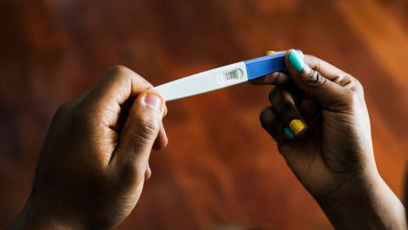

Adobe Stock

**CNN —**

A university in [Uganda](https://cnn.com/2022/10/17/world/uganda-ebola-lockdown-intl-hnk/index.html) has withdrawn a requirement for female nursing and midwifery students to take a pregnancy test before sitting their exams, after facing a backlash.

Kampala International University issued a notice on Tuesday stating: “This is to inform all female nurses and midwives that you are supposed to go to KIU-TH for a pregnancy test at a fee of 5000 UGX paid to hospital accounts office.”

It added: “Failure to do so, you will not sit for UNMEB (Uganda Nurses and Midwives Examinations Board) exams.”

The fee of 5,000 Ugandan shillings is about $1.33.

Epidemiologist Catherine Kyobutungi, executive director of the African Population and Health Research Center (APHRC), shared a [photo of the notice](https://twitter.com/CKyobutungi/status/1590238054517997568/photo/1) on Twitter on Wednesday and wrote: “This is total hogwash, discriminatory and unacceptable.”

She added: “Female nursing and midwifery students being asked to take a pregnancy test, at their own cost as a pre-condition for sitting exams is peak nonsense!!!”

Dr. Githinji Gitahi, CEO of non-profit Amref Health Africa, [responded](https://twitter.com/daktari1/status/1590363822224986113) by tweeting: “What? Why? Really? Because pregnancy has what to do with exams? The fetus gives undue advantage in the exam? I am so confused.”

[[](https://edition.cnn.com/2018/10/11/health/tanzania-pregnancy-test-asequals-intl/index.html)](https://edition.cnn.com/2018/10/11/health/tanzania-pregnancy-test-asequals-intl/index.html)

[They failed mandatory pregnancy tests at school. Then they were expelled](https://edition.cnn.com/2018/10/11/health/tanzania-pregnancy-test-asequals-intl/index.html)

Women’s rights organization FIDA Uganda [posted a photo of a letter](https://twitter.com/FIDA_Uganda/status/1590667525234491394/photo/1) it sent to the private university, reminding the institution that Article 33 (3) of the country’s 1995 Constitution “grants protection of women and their rights, taking into account their unique status and natural maternal functions in society and this same article further prohibits discrimination of women and guarantees their full and equal dignity of the person with men.”

On Thursday, the university reversed its policy.

“This is to inform you all that the internal memo on pregnancy and pregnancy testing dated 8 November 2022 has been rescinded (withdrawn),” wrote Professor Frank Kaharuza, deputy vice chancellor of the university’s Western Campus, in a statement shared by the university on [Twitter](https://twitter.com/kiuvarsity/status/1590615762674540544?s=20&t=qyD9onLNXNiHIc5jVHnqfw).

[[](https://edition.cnn.com/2022/10/06/health/ebola-airport-passenger-screening-uganda/index.html)](https://edition.cnn.com/2022/10/06/health/ebola-airport-passenger-screening-uganda/index.html)

[Airline passengers arriving to the US from Uganda will be routed through five airports for Ebola screening](https://edition.cnn.com/2022/10/06/health/ebola-airport-passenger-screening-uganda/index.html)

“Please focus on getting ready for your UNMEB exams. I wish you all the best in the forthcoming exams,” he continued.

The university also responded to FIDA Uganda in an email, shared by the rights group on [Twitter](https://twitter.com/FIDA_Uganda/status/1590667546013073408/photo/1), confirming that “no student will be stopped from sitting their exams because they have not taken a pregnancy test.”

FIDA Uganda tweeted: “We are grateful for the cooperation of the office of the vice chancellor and seek to remind all scholarly institutions that any attempts to police the bodies of students represents a discriminatory action against the student body and is a violation of their physical autonomy.”

CNN has contacted Kampala International University for comment.

**Netanyahu to be invited to form government, paving way for return of Israel’s longest-serving leader**

By Elliott Gotkine and Amir Tal, CNN

Updated 10:47 AM EST, Fri November 11, 2022



Benjamin Netanyahu speaks to supporters during a campaign event on October 29 in Bnei Brak, Israel.

Amir Levy/Getty Images

**Tel Aviv and JerusalemCNN —**

Israel’s President Isaac Herzog announced Friday he will invite [Benjamin Netanyahu](https://cnn.com/2022/11/02/middleeast/what-netanyahus-return-means-mime-intl/index.html) to form [Israel’s next government,](https://cnn.com/2022/11/02/middleeast/netanyahu-allies-intl/index.html) paving the way for him to take the country’s top job for a record sixth time and extend his record as the nation’s longest-serving leader.

Herzog will officially issue the mandate to Netanyahu on Sunday, he said. Herzog made the announcement after meeting with all the factions in parliament, the Knesset, to ask who they would back for prime minister.

In a statement released by his office, he said: “At the end of the round of consultations, 64 members of the Knesset recommended to the president the chairman of the Likud faction, MK Benjamin Netanyahu.” He added that 28 Knesset members recommended outgoing Prime Minister Yair Lapid. The same number chose not to recommend anyone.

Herzog will meet with Netanyahu at the president’s residence on Sunday to formally give him the mandate. Under Israeli law, Netanyahu will then have 28 days to form a new government, with the possibility of a 14-day extension if required.

During negotiations, Netanyahu will have to divide up ministries among his coalition partners and haggle over policies.

This is where things get interesting. With a four-seat majority in the 120-seat Knesset, or parliament, the five factions allied with Netanyahu’s Likud are all potential kingmakers: fail to give any one of them what they want, and they could bring the coalition down.

When it comes to the ultra-Orthodox parties, their demands are uncontroversial as far as Netanyahu is concerned: bigger budgets for religious schools, and the right not to teach their children secular subjects such as math and English.

The real showdowns are likely to come with his [new extreme right-wing allies](https://cnn.com/2022/11/02/middleeast/netanyahu-allies-intl/index.html). Netanyahu rode to power on the back of a stunning showing by the Religious Zionism/Jewish Power list, which, with 14 seats, is now the third-biggest grouping in the Knesset. Its leader, [Itamar Ben Gvir](https://cnn.com/2022/11/02/middleeast/netanyahu-allies-intl/index.html), who has a conviction for inciting anti-Arab racism and supporting terrorism, has demanded to be made Public Security Minister, in charge of Israel’s police.



Netanyahu ally Itamar Ben Gvir (left) has been convicted of inciting anti-Arab racism and supporting terrorism.

GIL COHEN-MAGEN/AFP via Getty Images

Ben Gvir’s partner is Bezalel Smotrich, who has described himself as a “proud homophobe.” He has said Israel should be run according to Jewish law. He has spoken of reducing the power of the Supreme Court, and striking out the crime of breach of trust – which just so happens to be part of the indictments against Netanyahu in his ongoing corruption trials. Netanyahu has long denied all of the charges. If Smotrich wins the Justice Ministry he covets, he may be able to make these things happen, ending Netanyahu’s legal worries.

Yet these may be the least of his concerns. Having been forced to join forces with the extreme right wing, the sixth reign of Netanyahu may end up further alienating the half of Israel that didn’t vote for the bloc of parties backing him.

Restrictions on settlements in the occupied West Bank could be loosened, prompting international condemnation. Violence between Israelis and Palestinians in the West Bank could worsen; 2022 has already seen more people killed on each side than any time since 2015.

Enter your email to sign up for CNN's "Meanwhile in the Middle East" Newsletter.

[close dialog](javascript:void(0))

Top of Form

Want an inside look at the biggest stories in the Middle East? ﻿

Sign Me Up

By subscribing you agree to our

[privacy policy.](https://www.cnn.com/privacy0?no-st=9999999999" \t "_blank)

Bottom of Form

Then there’s the potentially explosive issue of the Jerusalem holy site known to Jews as the Temple Mount and to Muslims as the Ḥaram al-Sharīf, or Noble sanctuary.

Under the status quo, only Muslims are allowed to pray at the compound. Ben Gvir advocates allowing Jews to pray at what is their holiest site.

Any change could be used as a pretext by Palestinian militants to carry out attacks. It would almost certainly be condemned by Israel’s new friends in the Arab world, such as Morocco, the UAE and Bahrain.

[[](https://edition.cnn.com/2022/11/02/middleeast/netanyahu-allies-intl/index.html)](https://edition.cnn.com/2022/11/02/middleeast/netanyahu-allies-intl/index.html)

[A far-right surge is set to put Netanyahu back in power. Who are his extremist allies?](https://edition.cnn.com/2022/11/02/middleeast/netanyahu-allies-intl/index.html)

President Herzog himself summed up the issue when a hot mic caught him telling Netanyahu’s allies in the Shas party: “You’re going to have a problem with the Temple Mount. That’s a critical issue. You have a partner that the entire world is anxious about,” an apparent reference to Ben Gvir.

Herzog told another of Netanyahu’s allies, Avi Maoz of the avowedly anti-LGBT Noam faction: “There has been concern about things you have said about the LGBT community. All human beings were created in God’s image and we must respect everyone. We have only one State of Israel. That pertains also to your party.”

Could a Netanyahu-led government have disputes with the United States? Netanyahu may not have the same bromance with President Joe Biden as he did with Donald Trump, but the two men seem to get along.

“We are brothers,” Biden told Netanyahu in a call after the election. “My commitment to Israel is unquestionable. Congratulations, my friend.”

Netanyahu replied: “We will bring more historic peace agreements [with the Arab world], that is within reach. My commitment to our alliance and our relationship is stronger than ever.”

Netanyahu is vehemently against the US rejoining the Iran nuclear deal, but that seems off the table for now. On Russia’s invasion of Ukraine, and Israel’s reluctance to provide Kyiv with defensive weapons, Netanyahu promised President Volodymyr Zelensky to “seriously examine” the issue.

Assuming Netanyahu can reach a coalition agreement by the December 11 deadline, the Knesset Speaker will call a confidence vote within seven days. If all goes to plan, Bibi’s government will then take office, perhaps on December 18 – in time for Hanukkah, the Jewish festival of lights (and miracles).

# Ukrainian troops sweep into key city of Kherson after Russian forces retreat, dealing blow to Putin

[[](https://www.cnn.com/profiles/mick-krever)](https://www.cnn.com/profiles/mick-krever)[](https://www.cnn.com/profiles/gianluca-mezzofiore)

By [Mick Krever](https://www.cnn.com/profiles/mick-krever), Anna Chernova, Teele Rebane, [Gianluca Mezzofiore](https://www.cnn.com/profiles/gianluca-mezzofiore), Tim Lister and Sophie Tanno, CNN

Updated 5:46 PM EST, Fri November 11, 2022

Video Ad Feedback



Iranian rapper charged with crimes punishable by death

02:51



Expert: 'Hate to admit' denuclearization of North Korea may be unrealistic

05:32



Video shows moment former Pakistan Prime Minister was shot

01:05



Inside China's 'zero-Covid' policy

04:59

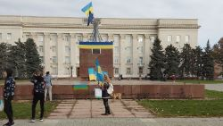

Ukrainians celebrate liberation as Russia pulls out of Kherson

02:34



Explained: How much damage can North Korea's weapons do?

02:53



UK swelters in what could be hottest day ever

03:41

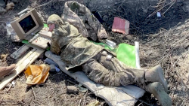

Field tool for female Ukrainian soldiers amazes Amanpour

03:52



Watch the moment the UN Secretary-General realizes he's reading the wrong speech at COP27

01:02



Stoltenberg: Partial Russian Kherson withdrawal shows NATO support is working

08:19



See Iranian soccer player appear to protest during tournament

04:22



CNN anchor presses Imran Khan to provide evidence of government involvement in shooting

10:38



Man was arrested after eggs were thrown at King Charles

00:47



UK town burns giant effigy of Liz Truss on Bonfire Night

01:02



Video shows passengers standing on top of plane after crashing

01:39



Iranian rapper charged with crimes punishable by death

02:51



Expert: 'Hate to admit' denuclearization of North Korea may be unrealistic

05:32



Video shows moment former Pakistan Prime Minister was shot

01:05



Inside China's 'zero-Covid' policy

04:59



Ukrainians celebrate liberation as Russia pulls out of Kherson

02:34



Explained: How much damage can North Korea's weapons do?

02:53



UK swelters in what could be hottest day ever

03:41



Field tool for female Ukrainian soldiers amazes Amanpour

03:52

**Kyiv, UkraineCNN —**

Ukrainian forces swept into the key [city of Kherson](https://edition.cnn.com/europe/live-news/russia-ukraine-war-news-11-11-22/h_8fdcc60a92516d454532293eecec1fdc) on Friday as Russian troops retreated to the east, delivering a major victory to Kyiv and marking one of the biggest setbacks for President Vladimir Putin since his invasion began.

Elated civilians who had survived months of Russian occupation descended on Kherson’s central square, hugging newly arrived Ukrainian soldiers, snapping selfies with them, and waving Ukrainian flags.

Footage of the jubilant scenes emerged hours after Russia announced it had withdrawn from the west bank of the Dnipro River in the strategic southern region of Kherson, leaving the regional capital of Kherson and surrounding areas to the Ukrainians.

The retreat represents a major blow for Putin’s war effort in Ukraine. Kherson was the only Ukrainian regional capital that Russian forces had captured since February’s invasion. Their withdrawal east across the Dnipro cedes large swathes of land that Russia has occupied since the early days of the war, and that Putin had formally declared as Russian territory just five weeks ago.

“The Ukrainian flag is raised in Kherson city. From now on, the Ukrainian flag will appear on all buildings in Kherson. This is what we have dreamed of from the first days of occupation,” said Serhiy Khlan, a member of Ukraine’s Kherson regional council.

On Friday evening, Ukraine’s President Volodymyr Zelensky posted a night-time video of celebrations in Kherson city, where a crowd was waving flags and chanting “ZSU,” the Ukrainian acronym for the armed forces.

He called it “a historic day” for Ukraine. “We are returning the south of our country, we are returning Kherson.”

“As of now, our defenders are on the outskirts of the city. Just a little more to go and we will enter. But special units are already in the city,” Zelensky said.

Zelensky appealed to any Russian soldiers still on the west bank to surrender.

“We guarantee that you will be treated in accordance with the law and international standards. And to those Russian military who disguised themselves in civilian clothes and are hiding somewhere, I want to say that you cannot hide. We will find you anyway,” he said.

Enter your email to subscribe to the CNN Business Newsletter.

[close dialog](javascript:void(0))

Top of Form



***BEFORE MARKETS OPEN***

***START YOUR DAY SMART***

Get essential news and analysis on global markets with CNN Business’ daily newsletter.

Sign Me Up

No Thanks

By subscribing you agree to our

[privacy policy.](https://www.cnn.com/privacy0?no-st=9999999999" \t ")

Bottom of Form

Ukrainian forces advanced through much of the Kherson region Friday, apparently encountering little or no resistance. Social media video from towns and villages throughout the region’s west bank shows troops being greeted by civilians.



Crowd cheer and chant as they surround a car with Ukrainian soldiers in Kherson's main square on Friday.

Reuters

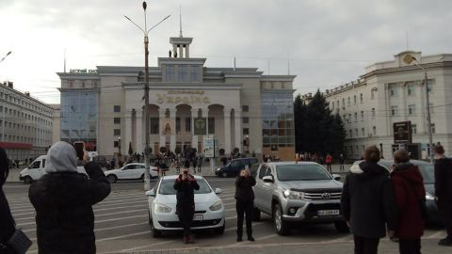

Residents raised Ukrainian flags in Kherson city, which was occupied by Russia until Friday morning.

Twitter

Russia’s Defense Ministry announced earlier on Friday that its forces have completed their partial withdrawal from the Kherson region, after Moscow [ordered the retreat](https://www.cnn.com/2022/11/09/europe/ukraine-russia-kherson-withdrawal-intl/index.html) Wednesday,

“In the Kherson direction, the move of Russian military units to the left bank of the Dnieper River was completed at 0500 [Moscow time] this morning,” the ministry said on its official Telegram channel, using the Russian spelling for the river.

“Not a single piece of military equipment or weaponry was left behind on the right [west] bank,” the statement added. “All Russian servicemen have moved to the left bank of the Dnieper.”

Social media video suggests otherwise, with Russian tanks, armored vehicles and crates of ammunition displayed by Ukrainian troops.

Ukraine has asserted that it carried out attacks against Russian troop concentrations that were withdrawing, but the Russian Defense Ministry said in a statement later on Friday that “despite the attempts of the enemy to disrupt the transfer of Russian troops, no losses among personnel, weapons, military equipment and materiel were allowed.”

It also claimed that the Ukrainian advance had been held back for several days, and that “manpower and military equipment of the Armed Forces of Ukraine on the right bank of the Dnieper are being hit by fire.”

Ukraine has not reported any incoming fire from the east bank Friday but said a missile attack on the city of Mykolaiv, close to the border with Kherson, killed seven people early Friday.

Earlier Friday, the Ukrainian military’s southern operational command said Russian forces had been “urgently loading into boats that seem suitable for crossing and trying to escape” across the river.

It was unclear whether all Russian troops had left Kherson and the wider region; Khlan said the city was “almost under the control of the Armed Forces of Ukraine” but warned that some Russian troops may have remained behind in civilian clothing.

He cautioned that many Russian troops “threw away their military uniforms, and are now hiding with civilian clothes on.”

“They will be plotting provocations, false-flag operations in the city,” he said. “There is a lot of work ahead on demining and clearing the city.” Residents of Kherson city with whom CNN has spoken in recent weeks confirmed that many Russian soldiers were using civilian clothing.

Ukraine’s military said it would proceed cautiously through Kherson region, and warned Russian troops were mining roads and destroying critical infrastructure [as they retreated](https://www.cnn.com/videos/world/2022/11/10/kherson-russia-retreat-ukraine-robertson-pkg-ovn-intl-hnk-vpx.cnn) from the region.

“The Russian invaders continue their looting of settlements from which they are retreating,” spokesman for the General Staff of Ukraine’s Armed Forces Oleksandr Shtupun said. “The enemy is also trying to damage power lines, other transport and critical infrastructure facilities of Kherson region.”

Images and video on social media Friday also showed that the Antonivskyi Bridge, the main conduit over the Dnipro in the Kherson region, had been destroyed.

At least seven bridges in total, four of them crossing the River Dnipro, have been destroyed in the last 24 hours, Maxar Technologies satellite images and other photos show.

Two bridges, a vehicle and a railroad, that sit atop a dam at Nova Kakhovka were among those destroyed.

Water is flowing out of three sluice gates at the critical dam, which spans the Dnipro river, according to satellite images from Maxar Technologies obtained by CNN.

It’s unclear how the latest damage, which is close to the west bank, was caused. Local Telegram channels reported Thursday night the sound of explosions around the dam. Ukrainian forces do not appear they have taken control of the dam, which could cause considerable damage in the region if breached.

Alexander Kots, a reporter for the Russian pro-government tabloid Komsomolskaya Pravda embedded with Russian forces, posted a video on his Telegram channel standing on the crossing, showing the entire center section of the bridge destroyed. “Behind me are the two collapsed spans of (the) bridge,” Kots said. “They were likely blown up during the withdrawal of the Russian group of forces from the right bank to the left,” or western bank to eastern bank.

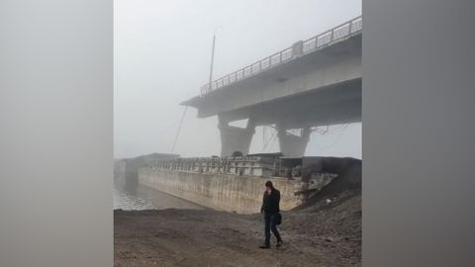

The entire center section of the bridge appears to have been destroyed.

Twitter

## Sweeping losses

Russian forces have ceded about 40% of the Kherson region, which straddles the Dnipro, within a few days.

Now that Ukrainian forces have recaptured Kherson as far as the Dnipro river, the two sides face each other across the river over a distance of some 250 kilometers – from the area around the Zaporizhzhia nuclear power plant to the edge of the Black Sea.

As Russian forces have fled, Ukrainian troops have pushed forward in their wake, capturing dozens of villages and settlements in Kherson region above the Dnipro.

The Ukrainian military on Friday recaptured another part of Kherson region, the village of Tyahinka near the strategic town of Nova Kakhovka, despite Russian forces destroying bridges to the village.

A video circulating on social media on Friday, geolocated and authenticated by CNN, showed Ukrainian forces being greeted by residents on the main highway in Tyahinka. The village is just 14 miles (20 km) west of the hydroelectric dam and bridges that stretch across the Dnipro river at Nova Kakhovka.

A number of photos, also geolocated and authenticated by CNN, show that the Ukrainian forces were able to make their way into the village despite the main highway’s bridge and a pedestrian bridge being destroyed by the Russians as they withdrew. Dozens of bridges across the Kherson region have been destroyed or disabled during the conflict.

Residents of the town of Bilozerka, on the western outskirts of Kherson city, raised a Ukrainian flag and ripped down Russian propaganda billboards on Friday, according to videos on social media geolocated by CNN.

One video showed a Ukrainian flag flying over a World War II memorial, while another showed residents tearing down a propaganda billboards with a young girl holding a Russian flag, which read: “Russia is here forever.”

The scenes of people greeting Ukrainian troops across the region were in sharp contrast to claims by Russian-appointed officials in Kherson six weeks ago that 87% of voters there supported integration into the Russian Federation, in a referendum widely condemned by the international community as a sham. Kherson was one of four Ukrainian regions illegally annexed by Russia in September.

[[](https://edition.cnn.com/2022/11/10/europe/kherson-gains-russia-retreat-intl/index.html)](https://edition.cnn.com/2022/11/10/europe/kherson-gains-russia-retreat-intl/index.html)

[Ukraine claims big gains in south, but fears retreating Russians will turn Kherson into 'city of death'](https://edition.cnn.com/2022/11/10/europe/kherson-gains-russia-retreat-intl/index.html)

Kyiv officials had warned that retreating Russian troops could turn the regional capital of Kherson into a [“city of death”](https://www.cnn.com/2022/11/10/europe/kherson-gains-russia-retreat-intl/index.html) on the way out, and an official in southern Ukraine warned residents Friday to be wary of quickly returning to recently liberated territory due to the threat of mines.

“There are a lot of mines in the liberated territories and settlements,” Vitaliy Kim, head of Mykolaiv region military administration, said on Telegram. “Don’t go there for no reason. There are casualties.”

Putin’s spokesperson on Friday insisted that the region remains part of Russia, despite the Russian withdrawal.

“This is a subject of the Russian Federation,” Dmitry Peskov said during a regular briefing with journalists. “It has been legally fixed and defined. There can be no changes here.”

Russia still controls a large portion of the Kherson region – the area east of the Dnipro River.

When asked directly whether Russia’s retreat was “humiliating” for President Vladimir Putin, Peskov replied: “No.”

# Chinese are criticizing zero-Covid — in language censors don’t seem to understand

By [Jessie Yeung](https://www.cnn.com/profiles/jessie-yeung), CNN

Updated 1:27 AM EST, Sat November 12, 2022

**Hong KongCNN —**

In many countries, cursing online about the government is so commonplace nobody bats an eye. But it’s not such an easy task on China’s heavily censored internet.

That doesn’t appear to have stopped residents of Guangzhou from venting their frustration after their city – a global manufacturing powerhouse home to 19 million people – became the epicenter of a nationwide Covid outbreak, prompting [lockdown measures](https://www.cnn.com/2022/11/09/china/china-covid-guangzhou-lockdown-intl-hnk) yet again.

“We had to lock down in April, and then again in November,” one resident posted on Weibo, China’s restricted version of Twitter, on Monday – before peppering the post with profanities that included references to officials’ mothers. “The government hasn’t provided subsidies – do you think my rent doesn’t cost money?”

Other users left posts with directions that loosely translate to “go to hell,” while some accused authorities of “spouting nonsense” – albeit in less polite phrasing.

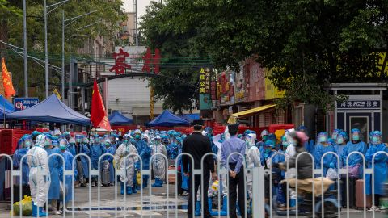

Workers dressed in white suits prepare to transfer residents, wearing blue protective suits, at a village in Guangzhou after a Covid outbreak on November 5.

Chinatopix/AP

Such colorful posts are remarkable not only because they represent [growing public frustration](https://www.cnn.com/2022/11/02/china/china-covid-foxconn-tibet-disney-intl-hnk) at China’s unrelenting zero-Covid policy – which uses snap lockdowns, mass testing, extensive contact-tracing and quarantines to stamp out infections as soon as they emerge – but because they remain visible at all.

Normally such [harsh criticisms of government policies](https://www.cnn.com/2022/10/22/china/china-party-congress-overseas-students-protest-intl-hnk/index.html) would be swiftly removed by the government’s army of censors, yet these posts have remained untouched for days. And that is, most likely, because they are written in language few censors will fully understand.

**AD**

Ad Feedback

These posts are in Cantonese, which originated in Guangzhou’s surrounding province of Guangdong and is spoken by tens of millions of people across Southern China. It can be difficult to decipher by speakers of Mandarin – China’s official language and the one favored by the government – especially in its written and often complex slang forms.

And this appears to be just the latest example of how Chinese people are turning to Cantonese – an irreverent tongue that offers rich possibilities for satire – to express discontent toward their government without attracting the notice of the all-seeing censors.

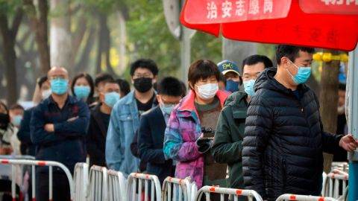

People in face masks wait in line for Covid-19 tests in Beijing, China, on November 10.

Mark Schiefelbein/AP

In September this year, US-based independent media monitoring organization China Digital Times noted numerous dissatisfied Cantonese posts slipping past censors in response to mass Covid testing requirements in Guangdong.

“Perhaps because Weibo’s content censorship system has difficulty recognizing the spelling of Cantonese characters, many posts in spicy, bold and straightforward language ​​still survive. But if the same content is written in Mandarin, it is likely to be blocked or deleted,” [said the organization](https://chinadigitaltimes.net/chinese/686516.html), which is affiliated with the University of California, Berkeley.

In nearby Cantonese-speaking Hong Kong, anti-government demonstrators in 2019 often used Cantonese wordplay both for protest slogans and to guard against potential surveillance by mainland Chinese authorities.

Now, Cantonese appears to be offering those fed-up with China’s continuous zero-Covid lockdowns an avenue for more subtle displays of dissent.

Jean-François Dupré, an assistant professor of political science at Université TÉLUQ who has studied the language politics of Hong Kong, said the Chinese government’s shrinking tolerance for public criticism has pushed its critics to “innovate” in their communication.

“It does seem that using non-Mandarin forms of communication could enable dissenters to evade online censorship, at least for some time,” Dupré said.

“This phenomenon testifies to the regime’s lack of confidence and increasing paranoia, and of citizens’ continuing eagerness to resist despite the risks and hurdles.”

## Perfect for satire, and protest

Though Cantonese shares much of its vocabulary and writing system with Mandarin, many of its slang terms, expletives and everyday phrases have no Mandarin equivalent. Its written form also sometimes relies on rarely used and archaic characters, or ones that mean something totally different in Mandarin, so Cantonese sentences can be difficult for Mandarin readers to understand.

Compared to Mandarin, Cantonese is highly colloquial, often informal, and lends itself easily to wordplay – making it well-suited for inventing and slinging barbs.

When Hong Kong was rocked by anti-government protests in 2019 – fueled in part by fears Beijing was encroaching on the city’s autonomy, freedoms and culture – these attributes of Cantonese came into sharp focus.

[[](https://edition.cnn.com/2021/12/15/tech/china-weibo-censorship-fine-mic-intl-hnk/index.html)](https://edition.cnn.com/2021/12/15/tech/china-weibo-censorship-fine-mic-intl-hnk/index.html)

[The Communist Party thinks China's prolific censors are not censoring enough](https://edition.cnn.com/2021/12/15/tech/china-weibo-censorship-fine-mic-intl-hnk/index.html)

“Cantonese was, of course, an important conveyor of political grievances during the 2019 protests,” Dupré said, adding that the language gave “a strong local flavor to the protests.”

He pointed to how entirely new written characters were born spontaneously from the pro-democracy movement – including one that combined the characters for “freedom” with a popular profanity.

Other plays on written characters illustrate the endless creativity of Cantonese, such as a stylized version of “Hong Kong” that, when read sideways, becomes “add oil” – a rallying cry in the protests.

Protesters also found ways to protect their communications, wary that online chat groups – where they organized rallies and railed against the authorities – were being monitored by mainland agents.

For example, because spoken Cantonese sounds different to spoken Mandarin, some people experimented with romanizing Cantonese – spelling out the sounds using the English alphabet – thereby making it virtually impossible to understand for a non-native speaker.

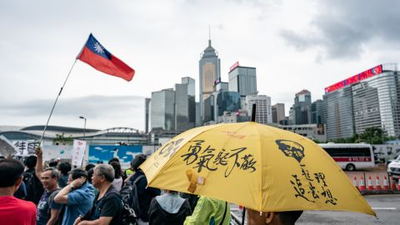

Protesters at a rally against a proposed extradition law in Hong Kong on May 4, 2019.

Anthony Kwan/Getty Images

And, while the protests died down after the Chinese government imposed a sweeping national security law in 2020, Cantonese continues to offer the city’s residents an avenue for expressing their unique local identity – something people have long feared losing as the city is drawn further under Beijing’s grip.

## Falling silent

For some, using Cantonese to criticize the government seems particularly fitting given the central government has aggressively pushed for Mandarin to be used nationwide in education and daily life – for instance, in television broadcasts and other media – often [at the expense of regional languages and dialects.](https://www.cnn.com/2019/04/09/asia/endangered-languages-welsh-hawaiian-cantonese-intl)

These efforts turned into national controversy in 2010, when government officials suggested increasing Mandarin programming on the primarily-Cantonese Guangzhou Television channel – outraging residents, who took part in rare mass street rallies and scuffles with police.

[[](https://edition.cnn.com/2019/04/09/asia/endangered-languages-welsh-hawaiian-cantonese-intl/index.html)](https://edition.cnn.com/2019/04/09/asia/endangered-languages-welsh-hawaiian-cantonese-intl/index.html)

[Welsh and Hawaiian were saved from extinction. Other languages might not be so lucky](https://edition.cnn.com/2019/04/09/asia/endangered-languages-welsh-hawaiian-cantonese-intl/index.html)

It’s not just Cantonese affected – many ethnic minorities have voiced alarm that the decline of their native languages could spell an end to cultures and ways of life they say are already under threat.

In 2020, students and parents in Inner Mongolia staged[mass school boycotts](https://www.cnn.com/2020/09/05/asia/china-inner-mongolia-intl-hnk-dst/index.html) over a new policy that replaced the Mongolian language with Mandarin in elementary and middle schools.

Similar fears have long existed in Hong Kong – and grew in the 2010s as more Mandarin-speaking mainlanders began living and working in the city.

“Growing numbers of Mandarin-speaking schoolchildren have been enrolled in Hong Kong schools and been seen commuting between Shenzhen and Hong Kong on a daily basis,” Dupré said. “Through these encounters, the language shift that has been operating in Guangdong became quite visible to Hong Kong people.”

[[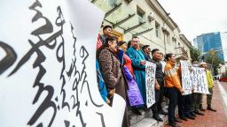](https://edition.cnn.com/2020/09/05/asia/china-inner-mongolia-intl-hnk-dst/index.html)](https://edition.cnn.com/2020/09/05/asia/china-inner-mongolia-intl-hnk-dst/index.html)

[How China's new language policy sparked rare backlash in Inner Mongolia](https://edition.cnn.com/2020/09/05/asia/china-inner-mongolia-intl-hnk-dst/index.html)

He added that these concerns were heightened by local government policies that emphasized the role of Mandarin, and referred to Cantonese as a “dialect” – infuriating some Hong Kongers who saw the term as a snub and argued it should be referred to as a “language” instead.

In the past decade, schools across Hong Kong have been encouraged by the government to switch to using Mandarin in Chinese lessons, while others have switched to teaching simplified characters – the written form preferred in the mainland – instead of the traditional characters used in Hong Kong.

There was further outrage in 2019 when the city’s education chief suggested that continued use of Cantonese over Mandarin in the city’s schools could mean Hong Kong would lose its competitive edge in the future.

“Given Hong Kong’s rapid economic and political integration, it wouldn’t be surprising to see Hong Kong’s language regime be brought in line with that of the mainland, especially where Mandarin promotion is concerned,” Dupré said.

## Speaking ‘without fear’

It’s not the first time people in the mainland have found ways around the censors. Many use emojis to represent taboo phrases, English abbreviations that represent Mandarin phrases, and images like cartoons and digitally altered photos, which are harder for censors to monitor.

But these methods, by their very nature, have their limits. In contrast, for the fed-up residents of Guangzhou, Cantonese offers an endless linguistic landscape with which to lambast their leaders.

It’s not clear whether these more subversive uses of Cantonese will encourage greater solidarity between its speakers in Southern China – or whether it could encourage the central government to further clamp down on the use of local dialects, Dupré said.

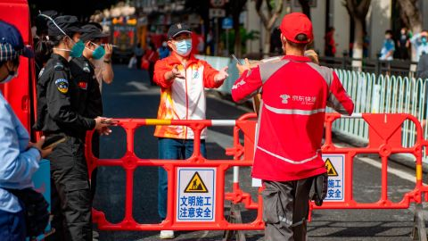

A delivery worker delivers a package to the entrance of a locked-down neighborhood in Liwan, Guangzhou, on November 9.

VCG/Getty Images

For now though, many Weibo users have embraced the rare opportunity to voice frustration with China’s zero-Covid policy, which has battered the country’s economy, isolated it from the rest of the world, and disrupted people’s daily lives with the constant threat of lockdowns and unemployment.

“I hope everyone can maintain their anger,” wrote one Weibo user, noting how most of the posts relating to the Guangzhou lockdowns were in Cantonese.

“Watching Cantonese people scolding (authorities) on Weibo without getting caught,” another posted, using characters that signify laughter.

“Learn Cantonese well, and go across Weibo without fear.”

**Haiti’s cholera death toll rises to 136 as outbreak gets ‘worse and worse every day’**

By Etant Dupain

Published 2:31 PM EST, Wed November 9, 2022



A woman sits next to a child as he receives treatment for cholera at the Gheskio Center Hospital supported by UNICEF in Port-au-Prince, Haiti ,October 14, 2022.

Ricardo Arduengo/Reuters

**CNN —**

A deadly resurgence of cholera in [Haiti](https://www.cnn.com/2022/10/29/americas/haiti-politician-killed-violence-intl/index.html) has claimed 136 lives so far, according to the Caribbean nation’s health ministry.

Eighty-nine of the people who were infected died in a hospital or in cholera treatment centers, while 47 of them died at home, according to the Haitian Health Ministry’s statement.

The Haitian government is working with international health organizations to respond to the crisis.

“We have been receiving 250 people a day lately. There’s a surge in cases in most parts of the metropolitan area. This is very concerning for us as we have a limited capacity with around 350 beds in our cholera treatment centers,” said Alexandre Marcou, a communications officer for medical NGO Médecins Sans Frontières, speaking to CNN on Wednesday.



A worker disinfects around a clinic run by Doctors Without Borders in Cité Soleil, Port-au-Prince, Haiti, October 7, 2022.

Richard Pierrin/AFP/Getty Images

People who live in areas with shortages of safe drinking water or inadequate sanitation are vulnerable to cholera, which can result from consuming bacteria-contaminated food or water.

Although vaccines exist and symptoms can be “easily treated,” according to the World Health Organization, cholera remains an insidious killer through dehydration in the developing world.

Just one month ago, the Health Ministry had documented only[eight cholera deaths](https://www.cnn.com/2022/10/05/americas/cholera-haiti-intl-latam), all in the densely populated capital Port-au-Prince.

[[](https://edition.cnn.com/2022/11/04/americas/haiti-gas-terminal-gang-intl-latam/index.html)](https://edition.cnn.com/2022/11/04/americas/haiti-gas-terminal-gang-intl-latam/index.html)

[Critical Haiti gas terminal freed after weeks of talks with G9 gang leader](https://edition.cnn.com/2022/11/04/americas/haiti-gas-terminal-gang-intl-latam/index.html)

Now, according to Marcou, the virus is spreading in remote areas of the country, which health services struggle to access and monitor.

“These places are harder to know what is going on there in real time due to the current crisis. It is clear the situation is getting worse and worse every day,” he said.

Until this year, the disease appeared to have been largely stamped out of the country, after a nationwide public health effort.

The last outbreak began in 2010, when cholera spread from a camp of United Nations peacekeepers into the population.

That outbreak ultimately reached 800,000 cases and claimed at least 10,000 lives. Though the UN has acknowledged its involvement in the outbreak, it has not accepted legal responsibility. Rights organizations have not stopped calling for financial compensation for victims.

**South Korean court approves extradition of woman accused of New Zealand ‘suitcase murders’**

[](https://www.cnn.com/profiles/yoonjung-seo)

By [Yoonjung Seo](https://www.cnn.com/profiles/yoonjung-seo), CNN

Published 3:49 AM EST, Fri November 11, 2022



A woman leaves the Seoul Central District Prosecutors' Office at Ulsan Jungbu police station in Ulsan, South Korea, on Sept. 15, 2022, after being questioned in connection with the finding of the remains of two children in suitcases in New Zealand.

Bae Byung-soo/AP

**SeoulCNN —**

A court in South Korea has approved the extradition of a woman [facing murder charges in New Zealand](https://www.cnn.com/2022/09/14/asia/new-zealand-children-suitcase-korea-woman-arrested-intl-hnk/index.html) in connection with a case in which the remains of two dead children were found in abandoned suitcases.

The Seoul High Court told CNN Friday it had ruled that the woman could be extradited, but that no date for this had yet been set and that the final decision now lay with the Justice Ministry.

The woman, a 42-year-old who police believe to be [the mother of the two children](https://www.cnn.com/2022/09/14/asia/new-zealand-children-suitcase-korea-woman-arrested-intl-hnk/index.html), was arrested in September in the southeastern city of Ulsan, weeks after the childrens’ remains were discovered in suitcases bought from a storage facility in New Zealand.

According to police, the woman was born in South Korea but moved to New Zealand “a long time ago” and gained citizenship before returning a few years ago.

She has denied the charges but agreed to be sent back to New Zealand, the Seoul High Court told CNN. New Zealand police have previously requested the woman be sent back under the two countries’ extradition treaty.

[[](https://edition.cnn.com/2022/09/14/asia/new-zealand-children-suitcase-korea-woman-arrested-intl-hnk/index.html)](https://edition.cnn.com/2022/09/14/asia/new-zealand-children-suitcase-korea-woman-arrested-intl-hnk/index.html)

[Woman arrested in South Korea in connection with alleged murder of two children found in suitcases in New Zealand](https://edition.cnn.com/2022/09/14/asia/new-zealand-children-suitcase-korea-woman-arrested-intl-hnk/index.html)

New Zealand police launched a homicide investigation in August after a family in South Auckland reported finding human remains in suitcases they bought in an online auction from a storage facility.

The children – likely to have been between ages 5 and 10 – may have been dead for around three to four years, according to New Zealand police.

At the time, police stressed the family who bought the suitcases were not under investigation.

# The World’s 10 Best Cities of 2023

## ***Unlike other best-of lists, Resonance’s annual ranking considers a city’s diversity, cultural programming, safety, number of parks, even sunny days.***

* Copy

LINK COPIED

* [Email](mailto:?body=The%20World%E2%80%99s%2010%20Best%20Cities%20of%202023%0A%0Ahttps%3A%2F%2Fwww.afar.com%2Fmagazine%2Fbest-cities-in-the-world%0A%0AThis%20new%20ranking%20considers%20outdoor%20experiences%2C%20diversity%2C%20safety%2C%20and%20a%20city%27s%20ability%20to%20innovate%20during%20the%20COVID-19%20pandemic.)
* [Facebook](https://www.facebook.com/dialog/share?app_id=430098855326056&display=popup&href=https%3A%2F%2Fwww.afar.com%2Fmagazine%2Fbest-cities-in-the-world)
* [Pinterest](https://pinterest.com/pin/create/bookmarklet/?url=https%3A%2F%2Fwww.afar.com%2Fmagazine%2Fbest-cities-in-the-world&description=The%20World%E2%80%99s%2010%20Best%20Cities%20of%202023&media=https://afar.brightspotcdn.com/1b/29/424c0a4ca923518fa62fe17e66e2/original-london-shutterstock-92655643.jpg)
* [Twitter](https://twitter.com/intent/tweet?url=https%3A%2F%2Fwww.afar.com%2Fmagazine%2Fbest-cities-in-the-world&text=The%20World%E2%80%99s%2010%20Best%20Cities%20of%202023)
* [Print](javascript:window.print())

Someday, we will start a story without referencing the “pandemic pause”—but this is not that day. Things are still in flux for the world’s best cities. In the past year, the global population started moving again en masse, in pursuit of the ideal place to work, live, and play. Hundreds of thousands left major metropolitan centers like New York, San Francisco, and Rome for more affordable pastures; meanwhile, LinkedIn reports that one in six job listings is “remote,” fueling somewhat of a planet-wide existential crisis. Does this spell the end for the big city?

“Far from it,” said Chris Fair, president and CEO of Resonance Consultancy, whose [2023 World’s Best Cities list](https://www.bestcities.org/rankings/worlds-best-cities/) was released today with many familiar destinations at the top.

For the past 15 years, Resonance—a consultancy group in real estate, tourism, and economic development—has taken a holistic approach to a popular “best-of” list. Rather than just rely on data around, say, a place’s [livability](https://www.afar.com/magazine/vienna-tops-the-list-of-the-most-livable-cities-in-the-world) or [how easy it is to bike there](https://www.afar.com/magazine/the-worlds-best-cities-for-biking-ranked), Resonance uses a combination of core statistics (like GDP and homicide rates) and qualitative evaluations by both locals and visitors (from online channels like Instagram and TripAdvisor) to paint a more comprehensive picture of a world’s best city. “It’s not just best city to live, it’s not just best city to work, or best city to visit,” said Fair. “It’s taking a cross section of all those factors.”

The cities on this year’s list—all with populations of more than 750,000—have used the “pandemic pause” to roll out 464 miles of bikeways (San Francisco), spend billions on hotels and waterfront development (Washington, D.C.), expand or open major museums and finally finish that LaGuardia airport renovation (NYC). One destination even changed its name—remember, [it’s now Istanbul, Türkiye](https://www.afar.com/magazine/why-turkey-is-now-turkiye). And common across so many of these top-tier cities is a commitment to diversity and sustainability: no longer “forward thinking,” now just the norm of the biggest thinkers.

One notable exception this year: “In our view, no city can be a ‘Best City’ that is part of a country that is taking unprovoked action against another,” says Fair. In response to Russia’s invasion of Ukraine, “we have removed Moscow and St. Petersburg from this year’s report, two cities that finished in the Top 20 last year,” and named Kyiv the 2023 Honorary World’s Best City.

## **How the best city rankings work**

“Many of the factors that people told us were important in choosing a city to live or do business or visit were related to the experiential quality of the city—things like culture, restaurants, nightlife, shopping, and sports,” Fair said. “There are no core statistics for those kinds of factors. What really distinguishes our rankings is that we are mining user-generated data in channels like TripAdvisor and Yelp to measure those experiential factors.”

Those areas they ranked cities on were grouped into six core categories, including Place, People, Programming, Product, Prosperity, and Promotion.

**Place:** This includes weather (the average number of sunny days), safety (homicide rate), as well as sights and landmarks (specifically the number of which were recommended by locals and visitors) and outdoors (or the number of parks and outdoor activities recommended by locals and visitors).

**People:** The People category considers educational attainment (percentage of population with a bachelor’s degree or higher) and percent of citizens participating in the labor force.

**Programming:**This is what most guidebooks would call “things to do” and includes experiences offered in the areas of culture (specifically performing arts), nightlife, dining, and shopping recommended by both locals and visitors.

**Product:** The Product category, on the other hand, includes each city’s infrastructure and institutions. This is where attractions and museums are considered, as well as other areas like airport connectivity (or the number of direct destinations served by the city’s airports), university ranking (specifically the ranking of the top local school), and the size of the local convention center.

**Prosperity:** This category includes the number of Global 500 corporate headquarters located within each city, the GDP per capita, the income equality index, and the unemployment rate. While most travelers wouldn’t necessarily factor these things into choosing a destination, Resonance believes greater “prosperity” draws more people to live in these cities, which eventually drives more economic growth and development. That means better dining options, cultural institutions, and airports in the long run.

**Promotion:**In addition to relying on user-generated data from locals and visitors to vet dining and shopping recommendations, this list also looked at how popular each city was online. The Promotion category—or how a city’s story is shared through online channels—is based specifically on the number of Facebook check-ins, Google searches, TripAdvisor reviews, and Instagram hashtags shared online about each city, as well as the popularity of each city in Google Trends over the last 12 months.

**Here’s how the world’s best cities ranked in the 2023 report, released November 9, 2022:**

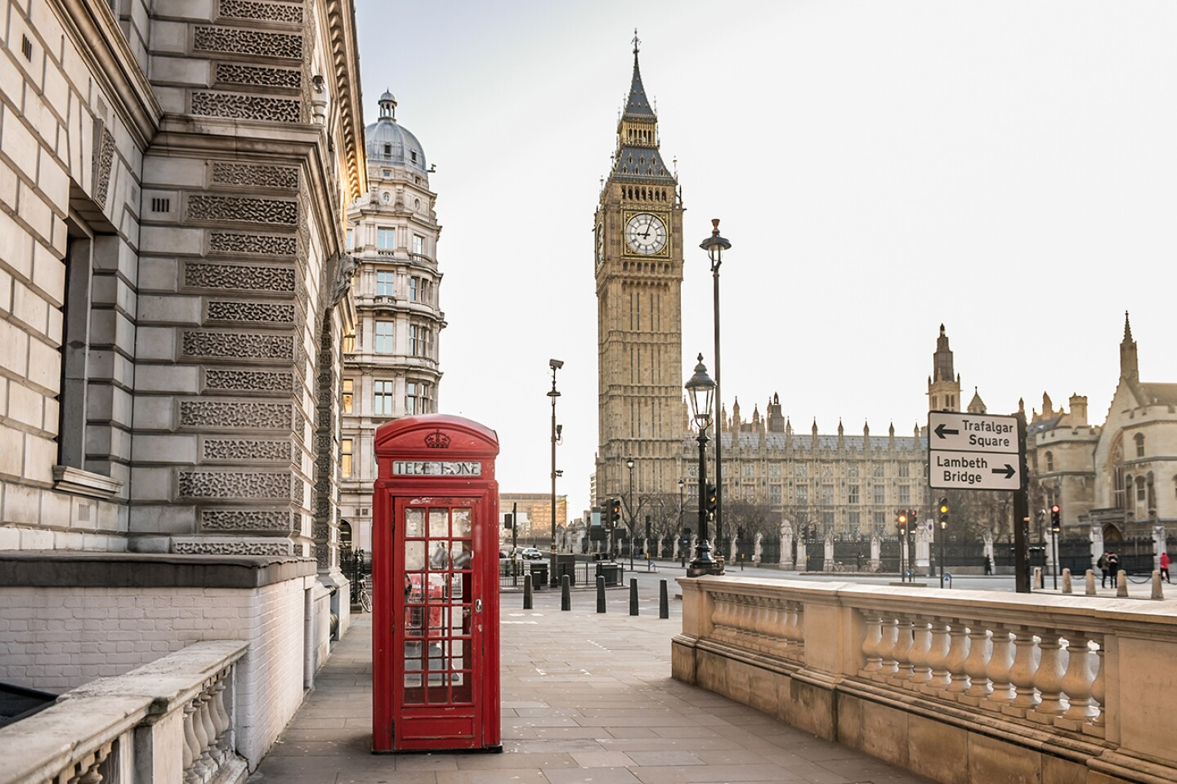

Photo by Shutterstock

## **1. London, England**

**Highlighted rankings: Nightlife (1), Museums (1)**

Despite a year when England’s longest-reigning monarch passed away … despite three prime ministers in mere months …“Despite much-warranted hand-wringing about the flight of talent and capital due to the pall of Brexit (and the follow-up specter of an airborne pandemic), **London is hanging in just fine**,” says Resonance, “relying on a dipping currency to attract investment and, of course, previously priced-out tourists. And new residents. New wealthy residents who can now afford to check off a big item on the multimillionaire bucket list: property in the best city on the planet. … According to fDi Markets, the *Financial Times’* foreign investment tracker, London has pulled in the most foreign direct investments into tech from international companies since 2018, ahead of New York, Singapore, and Dubai.”

**Why we love it**: London’s main sights might date back millennia, but the capital’s shops, bars, hotels, and restaurants continue to evolve on an almost weekly basis. Whether you’re outdoorsy, hungry, or bringing a family in tow, there’s a distinct [London neighborhood to investigate](https://www.afar.com/magazine/the-best-london-neighborhoods-for-every-kind-of-traveler)—and it will likely look different from your last visit. For [new hotel options](https://www.afar.com/magazine/best-new-london-hotels), there’s everything from the much-hyped NoMad London to hip One Hundred Shoreditch to revitalized historic classics such as the Dilly.

*Plan your next trip with AFAR’s*[*Guide to London.*](https://www.afar.com/travel-guides/united-kingdom/london/guide)

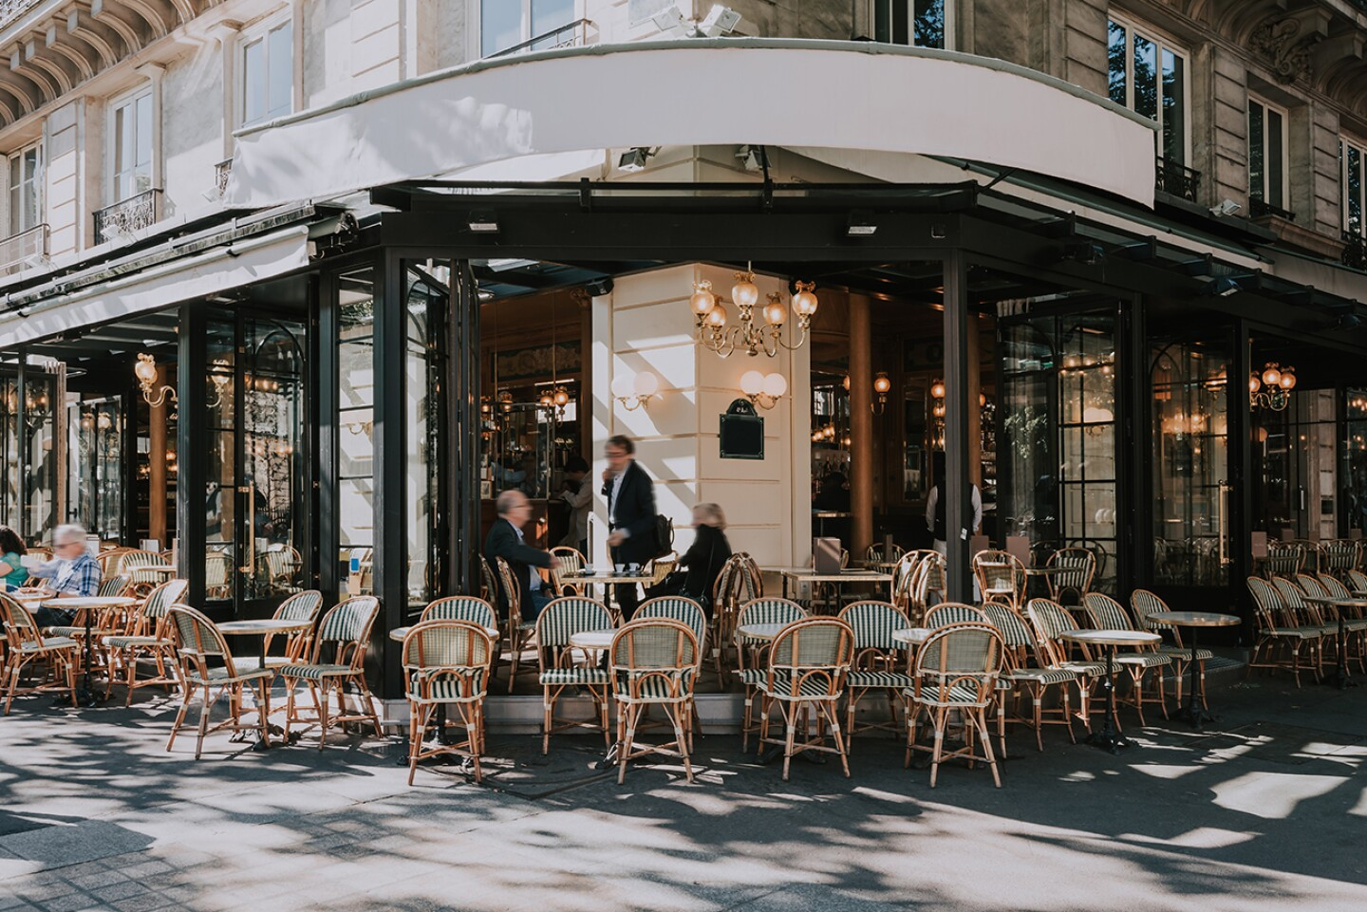

Photo by Catarina Belova/Shutterstock

## **2. Paris, France**

**Highlighted rankings:** Sights and Landmarks (1), Shopping (2)

“What returning visitors find is a city that has codified pedestrianism and alfresco living,” says Resonance. “To ensure cars didn’t take back control of Paris streets as pandemic urban pilot projects waned—as was the case in many other cities—Mayor Hidalgo legislated that the 60,000 parking spots loaned to restaurants for outdoor seating simply remained. … Nowhere is the transformation more dramatic than along the River Seine in the heart of Paris’s tourist district, near [Notre Dame Cathedral](https://www.afar.com/magazine/what-will-it-take-to-rebuild-notre-dame-cathedral) and city hall itself. With the reduced car traffic, this is now Paris’s town square (in a city with dozens of historic spots worthy of the honor). The riverside promenade hosted thousands night after night, even after Paris’s Right Bank summer event wrapped up. The Paris-Plages urban beach initiative welcomes picnicking and other low-cost access to a city long criticized as pricey and exclusive.”

**Why we love it:**As Paris gears up for the 2024 Olympics, it’s only getting better. Improved infrastructure, a commitment to pedestrianism, and a handful of [new hotels](https://www.afar.com/magazine/best-new-hotels-in-paris-2021-2022) in the past year alone add to a city we love for its world-class art, shopping, and global cuisine.

*Plan your next trip with AFAR’s*[*Guide to Paris.*](https://www.afar.com/travel-guides/france/paris/guide)

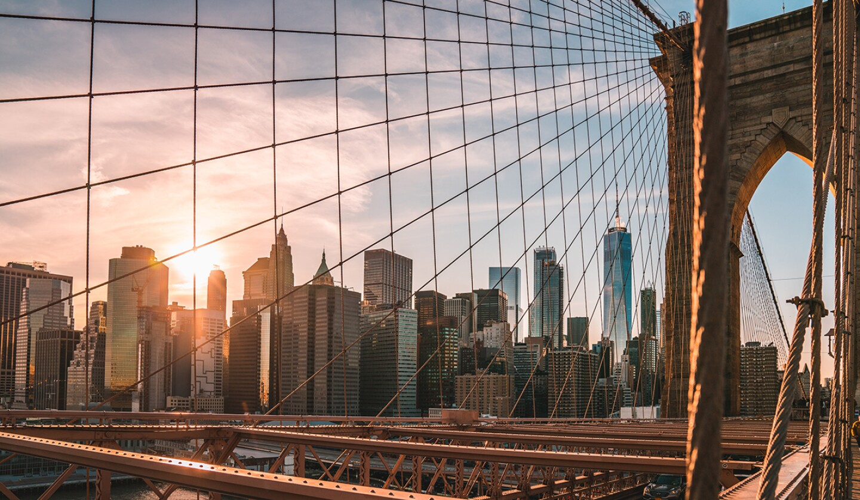

Photo by Colton Duke/Unsplash

## **3. New York City, United States**

**Highlighted rankings:** Promotion (2), Culture (2)

NYC is welcoming back visitors in style with major upgrades to its international gateways, says Resonance. LaGuardia Airport, Newark Liberty International Airport, and John F. Kennedy International Airport all have new terminals, “with the new Terminal B at LaGuardia alone boasting 35 gates” and [looking *fine*.](https://www.afar.com/magazine/laguardias-renovations-just-solved-everything-wrong-with-airport-bathrooms) “Back on the ground, Moynihan Train Hall is a new 17-track expansion of Penn Station that, if you squint, can pass for a northern European transit hub from the future.” And if you haven’t heard of the biggest hotel opening in the city this summer, just check out AFAR’s review of the [new $3,200-a-night Aman.](https://www.afar.com/magazine/inside-the-3-200-a-night-aman-new-york-manhattans-most-anticipated-hotel-opening)

**Why we love it:** “The City” consistently ranks for its culture; new this year is a Museum of Broadway, an expanded Louis Armstrong House Museum, the Bronx Children’s Museum, a jazz club with Lincoln Center acoustics at Aman. New to the Sights and Landmarks list: a slew of seriously legit food halls like the Singaporean/Malaysian Urban Hawker Center and the [Tin Building by Jean-Georges at revamped South Street Seaport.](https://www.afar.com/magazine/what-to-eat-see-and-do-in-south-street-seaport-nyc) And as Broadway comes back with a full roster, we expect visitors will follow.

*Plan your next trip with AFAR’s*[*Guide to New York City.*](https://www.afar.com/travel-guides/united-states/new-york/new-york/guide)

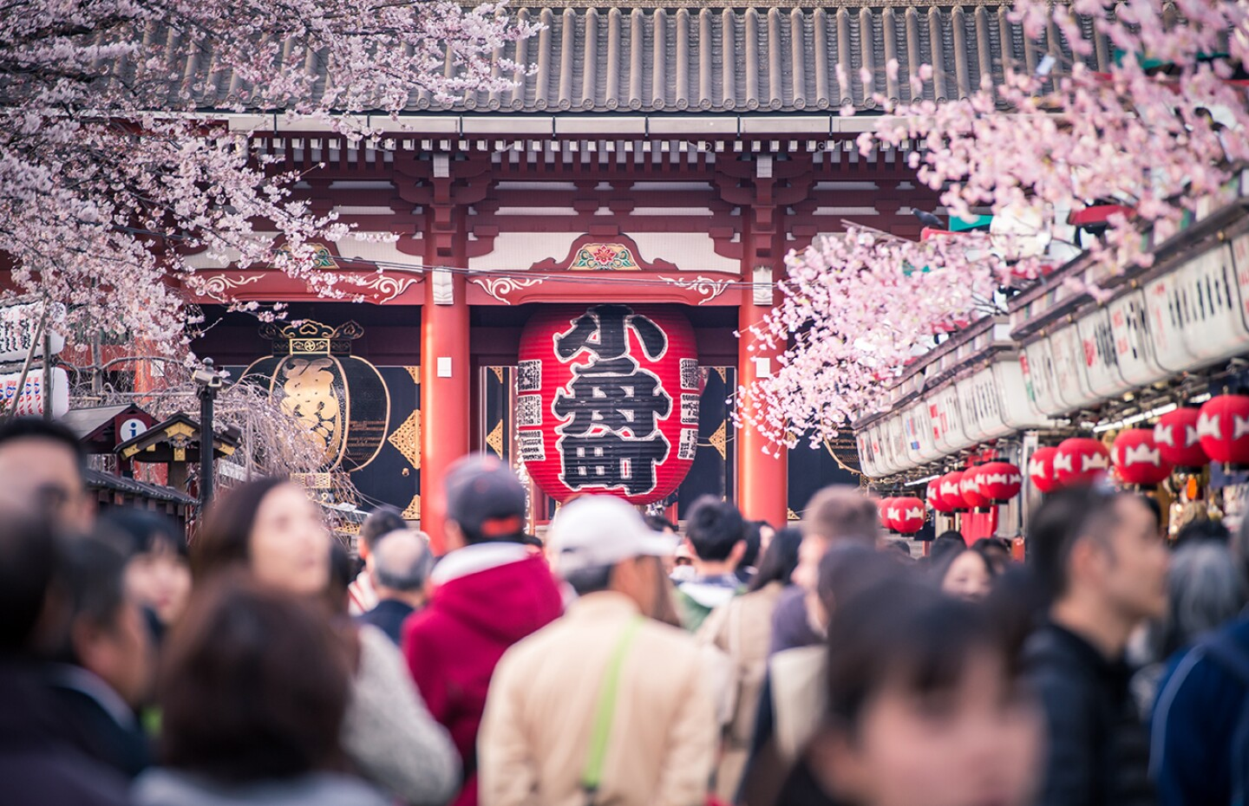

Photo by Shutterstock

## **4. Tokyo, Japan**

**Highlighted rankings:** Restaurants (1), Shopping (1)

“Despite the pandemic and subsequent derailment of Japan’s plans—or perhaps because of them—the Japanese government remains steadfast, keeping its target of 60 million visitors and $136 billion in tourism revenue by 2030. It’s not as delusional as it sounds: the country enjoyed record tourism for seven straight years and can now accommodate even more visitors to Tokyo, with the expansion of the international terminal at Haneda, the city’s main airport,” says Resonance. There’s much ado around [Japan’s recent reopening to international travelers](https://www.afar.com/magazine/how-traveling-in-japan-has-changed)—and as the world’s best city for shopping, wallets will likely open on their return.

**Why we love it:** Ranked no. 1 for its restaurants, Tokyo is home to some[life-changing ramen](https://www.afar.com/magazine/tokyos-long-lines-lead-to-magic-and-life-changing-ramen), making it a destination worth planning an entire trip around food. And if most of your travel budget goes to eating, don’t worry. There are plenty of [affordable hotels in Tokyo](https://www.afar.com/magazine/these-affordable-hotels-are-the-new-way-to-stay-in-tokyo) to book.

*Plan your next trip with AFAR’s*[*Guide to Tokyo.*](https://www.afar.com/travel-guides/japan/tokyo/guide)

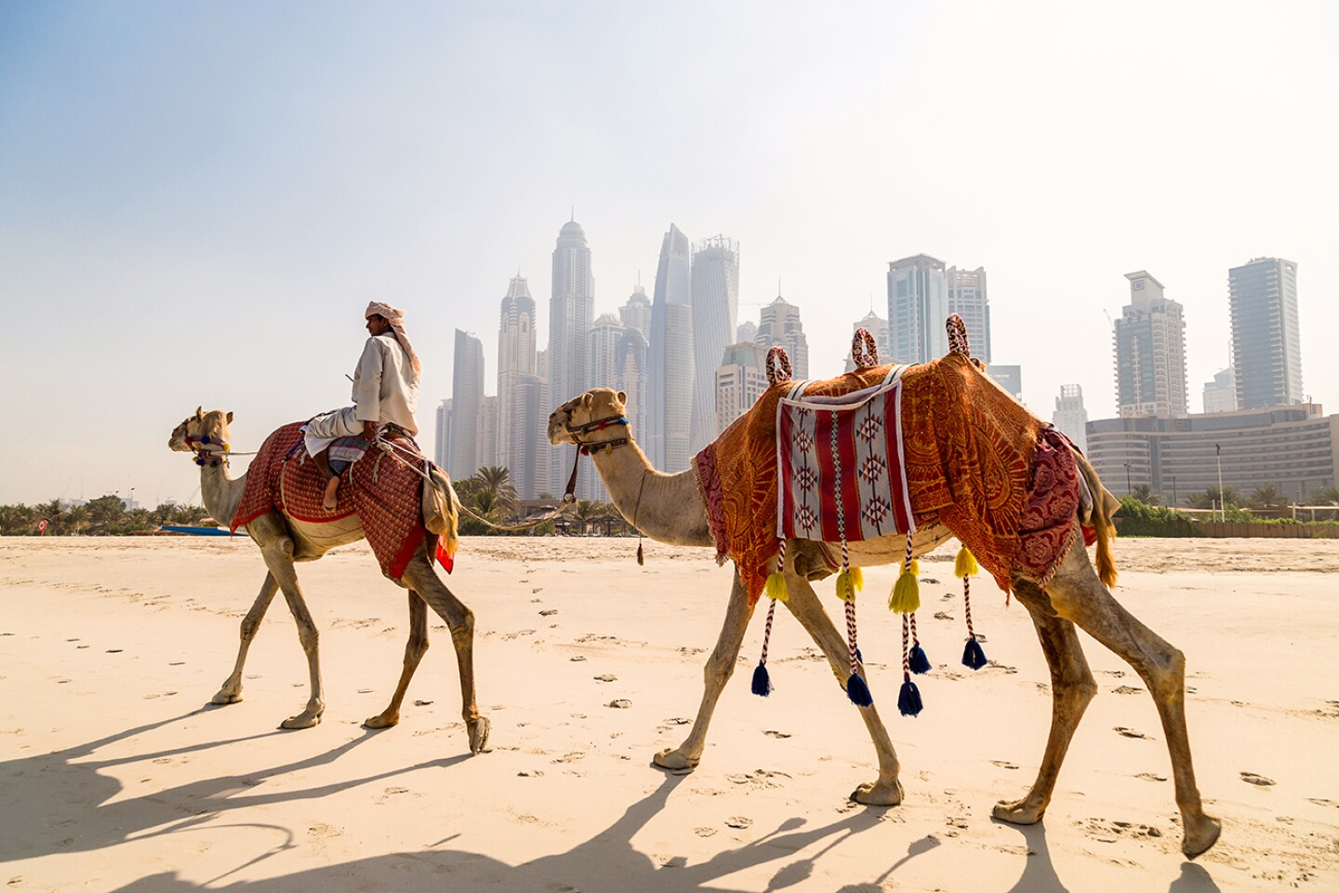

Photo by Shutterstock

## **5. Dubai, United Arab Emirates**

**Highlighted rankings:** Safety (1), Facebook Check-Ins (2)

Dubai is riding the high of [Expo 2020](https://www.expo2020dubai.com/) (which technically took place 2021–2022), a multibillion-dollar, six-month world’s fair showcasing nearly 200 nations with future-forward pavilions and seemingly round-the-clock cultural celebrations. Now the UAE hub wants to inspire loyalty (and repeat trips) among its visitors: Dubai is aiming to be the world’s most-visited tourist destination, targeting 25 million visitors by 2025. A new United direct flight between Newark and Dubai launches March 2023—that should help.

**Why we love it:** its new [Museum of the Future](https://museumofthefuture.ae/); greater accessibility with more affordable hotel options; a new Michelin guide featuring 69 restaurants, including a Green star sustainability honor; and the lure of Santiago Calatrava’s Tower at Dubai Creek, expected to eclipse the Burj Khalifa as the tallest building in the world.

*Plan your next trip with AFAR’s*[*Guide to Dubai.*](https://www.afar.com/travel-guides/united-arab-emirates/dubai/guide)

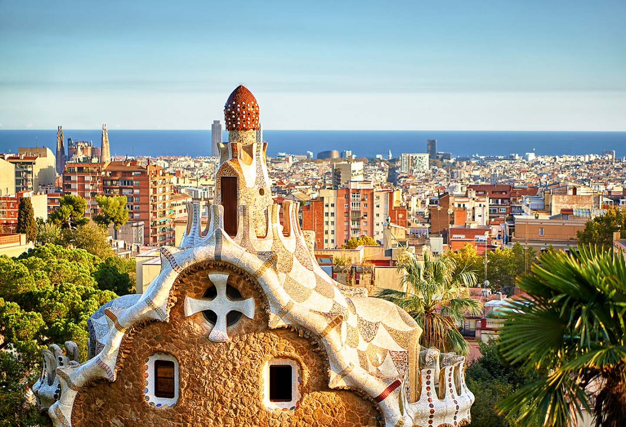

Photo by Luis Pina/Shutterstock

## **6. Barcelona, Spain**

**Highlighted rankings:** Nightlife (3), TripAdvisor Reviews (5)

**Why we love it:** Barcelona is an almost ideal European city, one with near-perfect weather year round,[miles and miles of beaches](https://www.afar.com/magazine/best-beaches-near-barcelona), iconic parks, [Gaudí’s iconic architectural landmarks](https://www.afar.com/magazine/5-essential-stops-in-gaudis-barcelona), and “colorful neighborhoods that march to their own beat—artistic, sophisticated, bohemian,” says Resonance. Now it can add “bike-friendly” to the list. “What visitors will find is more non-vehicular access to the city. Mayor Colau has delivered on her promise to reach 125 miles of bike lanes, with another 20 to be completed by 2023.” As part of the mayor’s “superblock” initiative, parking and roads have been replaced with playgrounds and public seating.

Just look to Passeig de Sant Joan, recently named one of the world’s best streets by *Time Out*. “Sant Joan is one of Spain’s first green corridors, designed for self-propelled mobility and exploration with its bicycle lanes, expansive sidewalks, greenery and sprawling outdoor seating,” says Resonance. “Extra bonus: it’s also home to the city’s beloved food market, Mercat de l’Abaceria (at least until it moves into more permanent digs later this decade).”

*Plan your next trip with AFAR’s*[*Guide to Barcelona.*](https://www.afar.com/travel-guides/spain/barcelona/guide)



Photo by Christopher Czermak/Unsplash

## **7. Rome, Italy**

**Highlighted rankings:**TripAdvisor Reviews (2), Sights and Landmarks (3)

“Few cities serve up the ability to walk Western history like Roma. Heck, Palatine Hill alone invites you into two millennia’s worth if you’ve got an hour,” says Resonance. “A dozen other museums and cultural landmarks have also just reopened or have been unveiled for the first time,” says Resonance. “Don’t miss the reopened Mausoleum of Augustus as well as the Casa Romana, a 4th-century residence underneath the Museo di Scultura Antica Giovanni Barracco. Newcomers include the Museo Ninfeo, which chronicles the ruins of a… let’s call it ‘vacation property’… for Roman emperors.”

**Why we love it:** Rome’s ancient charms are evident in every cobbled street, but the city never rests on its laurel wreaths. New reasons to visit the city include [the city’s first Hoxton hotel](https://www.afar.com/magazine/13-exciting-hotel-openings-for-2021-in-the-us-and-europe) and upcoming [renovations to the Colosseum](https://www.afar.com/magazine/rome-to-rebuild-colosseums-ancient-retractable-floor)—[just be sure not to sit on the Spanish Steps](https://www.afar.com/magazine/rome-bans-sitting-on-the-spanish-steps) when you return.

*Plan your next trip with AFAR’s*[*Guide to Rome.*](https://www.afar.com/travel-guides/italy/rome/guide)

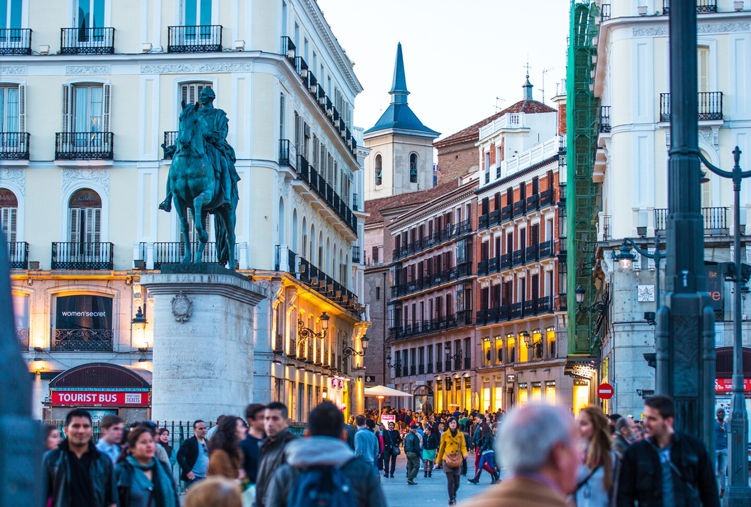

Photo by Yulia Grigoryeva/Shutterstock

## **8. Madrid, Spain**

**Highlighted rankings:**Nightlife (6), Trip Advisor Reviews (7)

Up from the 10th spot, Madrid has “bounced back on its feet deftly, continuing a much-needed investment in its bounteous (but long-dormant) infrastructure and public assets that is fueling the Spanish capital’s city-building legacy like few eras before,” says Resonance. “Perhaps the biggest news is Madrid’s beautiful measures to combat climate change and pollution, by way of a 47-mile urban forest network with nearly half-a-million new trees that will connect the city’s existing forest masses and reuse derelict sites between roads and buildings. Upon completion, this ‘green wall’ is projected to help absorb 175,000 tons of carbon dioxide per year, and mitigate heat generated by urban human activity.”

**Why we love it:** Spain’s capital is best explored on foot—strolling its wide boulevards or wandering down the halls of the Reina Sofia or Prado museums. But be sure to indulge in an afternoon siesta, since Madrid’s nightlife scene is not to be missed. In fact, when AFAR sent novelist Mira T. Lee on a[last-minute trip to Spain](https://www.afar.com/magazine/why-spain-is-the-best-place-to-rekindle-a-love-of-late-nights) in 2019, she rediscovered her love of late nights watching flamenco shows and dancing at clubs in the city’s Cheuca neighborhood. COVID has curtailed some of the nocturnal fun, but investments in outdoor dining and walking infrastructure should see the city bounce back when the virus eventually recedes.

*Plan your next trip with AFAR’s*[*Guide to Madrid.*](https://www.afar.com/travel-guides/spain/madrid/guide)

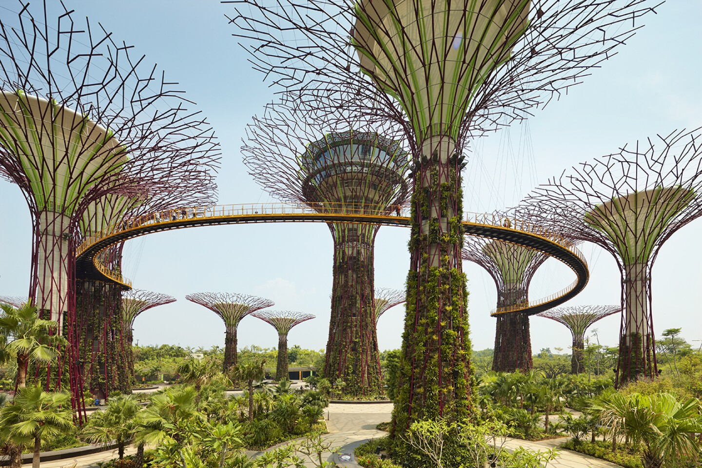

Photo by Shutterstock

## **9. Singapore**

**Highlighted rankings:** Safety (4), Google Trends (4)

**Why we love it:** “Singapore’s reinvestment into research, talent, and corporate headquarters recruitment ensures it will be home to a sustainably wealthy citizenry for decades to come. It’s why the city-state continues its ascent among the planet’s most prosperous cities,” says Resonance. The Little Red Dot, as the city-state is affectionately called, earned high rankings for Safety and Foreign-Born Population; it earns top spots in our eyes (and stomachs) for its famous[hawker stall](https://www.afar.com/magazine/best-hawker-centers-in-singapore-and-what-to-eat-there) street food, its [garden-like airport terminal](https://www.afar.com/magazine/inside-singapores-new-jewel-complex-at-the-worlds-best-airport), and the [reopened](https://all.accor.com/pdf/raffles_hotel_reopenings-en.pdf) Raffles Singapore hotel, which has been welcoming travelers since 1887. Keep an eye out for the results of the Singapore Green Plan 2030, which includes “800-plus miles of bike lanes and the recently reopened nine-mile Rail Corridor,” says Resonance.

*Plan your next trip with AFAR’s*[*Guide to Singapore*](https://www.afar.com/travel-guides/singapore/guide)

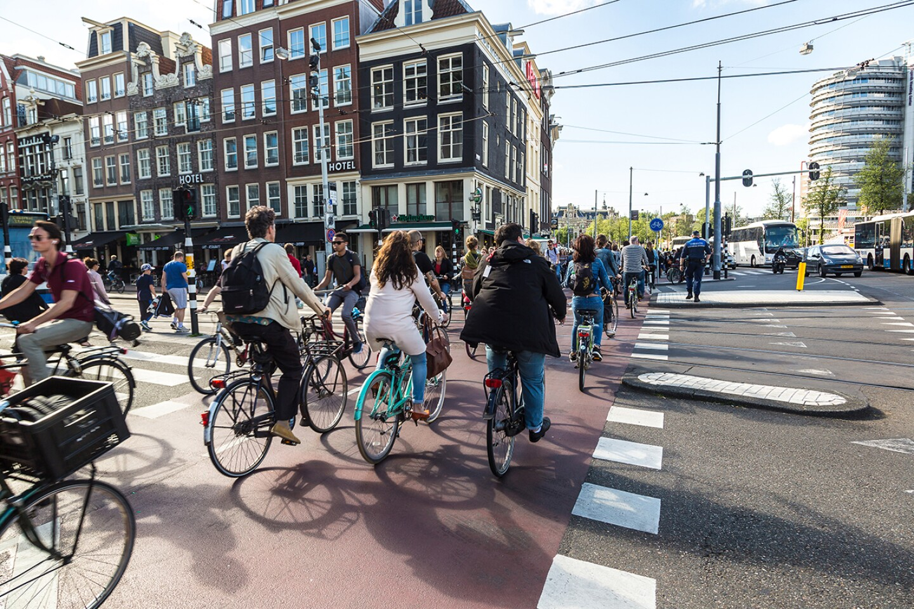

Photo by Shutterstock

## **10. Amsterdam, Netherlands**

**Highlighted rankings:**Income Equality (3), Labor Force Participation (5)

“The smallest city in the Top 50 is a tiny but mighty dynamo to keep an eye on, led by visionary mayor Femke Halsema (literally: she’s also a filmmaker), the first non-interim female mayor in the city’s history,” says Resonance. “Her administration’s practical stewardship of a place (and citizens) often abandoned to the tourist euro is co-authoring a future of accountability by everyone who calls the magnetic Dutch capital home.”

**Why we love it:** With nonstop flights available from most U.S. cities, Amsterdam’s easy accessibility—and beautiful canals and world-class museums—make it a popular stop for any Euro trip. In addition to its top-notch cultural offerings, Amsterdam is also on the forefront of sustainable tourism. In 2018, one hospitality company started to repurpose Amsterdam’s out-of-use bridge houses into charming [stand-alone hotel rooms](https://www.afar.com/magazine/amsterdams-tiny-bridge-houses-are-now-one-of-a-kind-hotel-suites), and by 2030, all [gas and diesel cars will be banned](https://www.afar.com/magazine/amsterdam-is-banning-all-gas-and-diesel-vehicles-by-2030) from the city.